Tackling Climate Change: Determinants of Legislator Support for Gas Taxes

April 8, 2021

When we understand the differential policy costs across constituencies and thus the source of legislators’ policy opposition, we can design policy interventions to solve pressing problems. We study the role of policy costs on constituents by studying legislator support for taxing gasoline. Our survey of U.S. state legislators shows that legislators whose constituents would be most affected by an increased gas tax – those whose constituents have longer commutes – are more likely to oppose increases to the gas tax. Further analysis separately estimates the impact of time spent driving alone to work versus using public transit. The effect of commute times comes from those who have long drives, not from those who ride public transit, highlighting how the policy costs to constituents is a major driver in legislators’ considerations. We finish the paper by discussing the implications of our findings for combating climate change.

In democratic governments, the relationship between constituents and legislators is crucial to understanding policy outcomes. Legislators who are not responsive to constituents’ preferences risk losing their next election (Canes-Wrone, Brady, and Cogan 2002). Yet responsiveness is not without its downsides. Legislators’ electoral concerns and resulting focus on constituents’ policy interests may sometimes lead to myopic policymaking (Healy and Malhotra 2009). Policies with significant long-term benefits may lack legislative support if they impose short-term costs on electorally influential constituencies. Thus, the likelihood of policy change in many domains involves understanding who benefits from the status quo and who might be hurt by a change in policy, particularly as government policies can have differential costs across groups. When we understand the source of policy opposition in the constituency, then we can design policy interventions that change the costs of the policy in ways that facilitate policy change to solve pressing problems. In this paper we study how much US state legislators’ policy preferences over their state’s gas tax are related to the direct impact that the gas tax has on their constituents.
We study the gas tax because climate change is a critical issue and raising taxes on gasoline is an important policy tool that mitigates climate change (Klenert et al. 2018; Lin and Li 2011; Metcalf 2009). Because the federal gas tax is low relative to other OECD countries (Alternative Fuels Data Center 2018) and because there is substantial variation in excise taxes across US states (Cammenga 2020), studying the preferences of state legislators on this issue can provide insights into the conditions that might foster support for a higher gas tax across states and at the federal level. If a change in policy, an investment in a related area, or a different policy design can reduce the costs that some constituents face from a higher gas tax, more legislators may be willing to support a higher gas tax, thereby helping reduce carbon emissions.
We examine the relationship between constituents’ policy interests and legislators’ preferences by testing whether legislators’ positions on their state gas tax is affected by how much a higher gas tax would impact their constituents. Studies have found mixed support for whether the policy impact can have an independent effect on legislators’ votes (Adler, Cayton, and Griffin 2018; Bussing et al. 2020). We look at the direct policy impact by measuring how much people in the community drive for their commute. We also control for several other factors including the legislators’ partisanship, employment in industries likely to be most affected by the gas tax, the ideology of voters in the district, and more (Anderson 2011; Levitt 1996). We find that those legislators whose constituents would be directly affected by an increased gas tax – those whose constituents drive more – are more likely to oppose increases to the gas tax.
Our results provide a hopeful note in the effort for climate change mitigation because they suggest that public transit can have a double climate dividend. Use of public transit instead of personal vehicles can have a direct effect on reducing carbon emissions by increasing the fuel efficiency of passenger miles (Lowe et al., 2009). Further, transit substitution can have indirect effects on carbon emissions by increasing legislators’ support for a higher gas tax.

Why the Gas Tax Matters to Constituents
The need to win reelection in order to retain office incentivizes legislators to be less supportive of legislation that will negatively impact their constituents (Adler, Cayton, and Griffin 2018; Butler and Nickerson 2011; Jackson and Kingdon 1992; Kau and Rubin 1982; Peltzman 1984), especially when it is a salient issue for voters (Bélanger and Meguid, 2008; Lax and Phillips, 2012). The gas tax is likely to be one of these salient issues. The purchase of motor fuel accounts for five percent of all consumer expenditures (Anderson et al., 2013). Moreover, past work has found that rising gas prices reduce presidential approval (Harbridge et al., 2016), pointing to how elected officials are penalized for costs faced by constituents and why legislators might be attentive to the impact of gas taxes on constituents. Importantly, however, the impact of higher gas taxes is not felt evenly across people or constituencies. Given the structure of the gas tax – cents per gallon of fuel – any gas tax increase will have its largest impact in areas where people rely most on gas for transportation. Thus, as commute times increase, the gas tax has a larger impact on voters’ pocketbooks. We therefore expect legislators whose constituents face longer commute times to be less supportive of gas tax increases.
To avoid omitted variable bias in testing the impact of voters’ commute times on legislators’ gas tax preferences, we control for confounding factors that might be correlated with commute times and also affect legislators’ positions on the gas tax. Thus, we control for the proportion of the district working in agriculture, mining, and transportation (Decker and Wohar, 2007), which are industries that are disproportionately impacted by a gas tax and also are likely to be in areas with longer commute times. We control for the ideology of the district (Tausanovitch and Warshaw, 2013) because more conservative districts might oppose taxes on principle and also tend to be more rural districts (Rodden, 2019) with longer commute times. We control for party because the electoral process typically produces a correlation between district preferences and legislators’ partisanship (Miller and Stokes, 1963), and party may be tied to preferences on the issues of taxation and climate change. Because previous research has shown that education and income predict support for gas taxes (Dietz et al., 2007; Rienstra et al., 1999; Thalmann, 2004), and these factors are likely correlated with how urban the district is (Cromartie, 2017; Marré, 2017), we also control for the median income in the district and the proportion of the population with a college degree.

Methods
To study legislators’ preferences on the gas tax and what factors shape these views, we combine a survey of state legislators’ views on the gas tax with estimates of district preferences from national surveys and administrative data from the US Census. In June 2014 we sent all state legislators with a publicly available email address on their state’s website an invitation to complete a 5-minute survey. The email came from the university account of one of the authors. We sent follow up emails one and two weeks after the initial invitation as reminders to legislators who had not completed the survey. We subset the analysis to only include the 346 respondents who self-identified as state legislators not staff. The sample is generally representative of the population of state legislators on a variety of demographic and institutional attributes like party, gender, majority/minority status, and term limited or not. See Appendix A for more information about the representativeness of the legislator sample.
Measurement of Gas Tax Preferences for the Dependent Variable
In the survey, we reminded the legislators what the current gas tax in their state was and then asked them to report the preferences of their party leaders, the preferences of their constituents, and their own personal preferences. After asking them about these three factors separately, we asked them to indicate the level of the gas tax that they would implement in their role as a state legislator if they could choose. Specifically, we asked the following question, which is our main dependent variable in the analysis:
We realize that many factors go into making decisions as a state legislator. Accounting for all of the above considerations (and other factors too), what would you implement if, in your role as a state legislator, you could choose the state gas tax level in your state?
The survey allowed respondents to choose a gas tax level in cents-per-gallon using a slider with bounds between 0 and 150. Only two respondents chose a gas tax level of 150.

Measuring the Policy Impact of Higher Gas Taxes and Other District Characteristics.
For the direct policy impact of gas taxes on constituents, we use commute time data from the American Community Survey (ACS). Specifically, we use that data to look at the percentage of the workforce working outside of their home who have a commute time of 60 or more minutes. As a robustness test, we also look at the percentage of the workforce with a commute time of 30 or more minutes. Because commuters who drive by private car will feel the impact of a higher gas tax much more than constituents who commute by public transit, we also conduct a follow up analysis that separately estimates the impact of time spent driving alone to work versus using public transit.
We also used the ACS data to measure industry employment, education, and income in the district. With regards industry employment, we calculated the proportion of the district that is employed in three industries that would be most affected by a gas tax increase: Mining and Oil; Agriculture; and Transportation and Warehousing. We measure educational attainment in the district by using the proportion of the district with at least a bachelor’s degree (bachelor’s degree, master’s degree, professional degree, and doctorate’s degree). For income, we use the median household income measure in the ACS. More information about how we use the ACS to calculate these measures can be found in Appendix B.
We measured the ideology of the constituents in each state legislative district using Tausanovitch and Warshaw’s (2013) district constituency ideology estimates. Tausanovitch and Warshaw create the measure using 275,000 survey responses from the Annenberg National Election Study and the Cooperative Congressional Election Study from 2000 to 2011 using Item Response Theory.

Survey Responses Predict Real-World Voting Behavior
Survey responses do not always accurately measure how people behave; however, one advantage of studying legislators is that we have information on how some of them voted on an actual gas tax increase in their legislature around the same time we conducted the survey. We test whether the survey responses predict how legislators voted on legislation in order to learn whether these survey responses provide a meaningful guide to how they will behave when considering policy change.
We focus on New Hampshire and Wyoming, both of which had a vote on the gas tax about the same time as our survey. Figure 1 presents data about how the 25 survey respondents from New Hampshire voted on Senate Bill 367 – a bill to increase the gas tax – in 2014. The vertical lines in Figure 1 give the status quo gas tax at the time (18 cents per gallon) and the new gas tax level proposed in SB 367 (22.2 cents per gallon). The points in the graph indicate the legislators’ preferred gas tax (from the survey) and their vote on SB 367. Figure 1 shows that legislators who reported preferring a gas tax closer to the proposal than to the status quo were much more likely to vote for the proposal. In fact, only four legislators whose preferences were closer to the proposal voted against it and only two whose preferences were closer to the status quo voted for it. The curved line shows the predicted probabilities of voting “yes” derived from a logistic regression, along with 95% confidence intervals. Wyoming legislators voted on a similar bill that increased the gas tax from 14 to 24 cents per gallon. In a logistic regression controlling for party, a legislator’s preference for the proposed gas tax relative to the status quo (operationalized as |Status Quo Gas Tax Level – Legislator’s Ideal Gas Tax Level| − |Proposed New Gas Tax Level – Legislator’s Ideal Gas Tax Level|) is a significant predictor of voting behavior (p < .05; see SI Table 2). This shows that legislators’ self-reported gas tax preferences in the survey were meaningful responses that represent their real-world stances.

Figure 1: Survey Preferences and Gas Tax Voting in New Hampshire
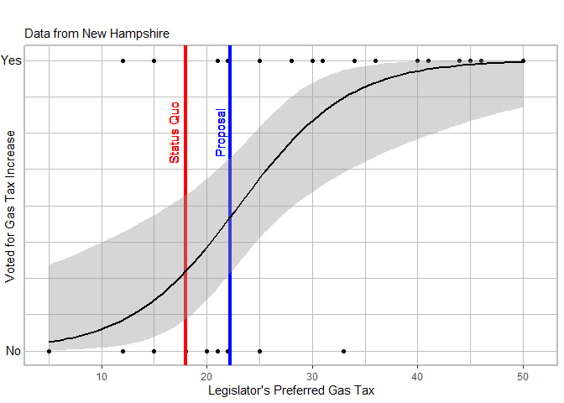
Commute Times for Constituents Predict Legislators’ Gas Tax Preferences
Figure 2 shows that constituent commuting burdens are an important predictor of legislators’ preferences for a lower gas tax level. Figure 2 plots the coefficients and the associated 95% confidence intervals from a regression where the dependent variable is the legislator’s preferred gas tax level as reported in the survey (see SI Table 3 for full regression results, which include fixed effects by state). We run two separate regressions, one that includes the proportion of people in the legislator’s district with a commute time of over sixty minutes and another with the proportion of people in the legislator’s district with a commute time of over thirty minutes. In both regressions, constituents’ commuting burden is negatively correlated with the legislator’s preferred gas tax. A one percentage point increase in the share of commuters over sixty minutes is associated with a 0.66 cent lower preferred gas tax. Likewise, a one percentage point increase in the share of commuters over thirty minutes is associated with a 0.26 cent lower preferred gas tax. Robustness checks with commute measured on a 9-point ordinal scale show that a legislator with a median commute time in their district that is one point lower prefers a gas tax that is 3.5 cents lower (see SI Table 3, model 3). These estimates control for district ideology in general, so the estimates represent the correlation of preferences with commute times above and beyond the liberal or conservative bent of the district. Once we account for commute times, the ideology variable is not statistically significant. Employment in affected industries, district median income, and district education are not associated with legislators’ gas tax preferences either. Partisanship is the only control variable that is significant and we find that it goes in the expected direction. Democratic legislators support, on average, a 12 cent higher gas tax than Republican legislators.

Figure 2: Gas Tax Preferences Decrease with Constituent Commute Times.
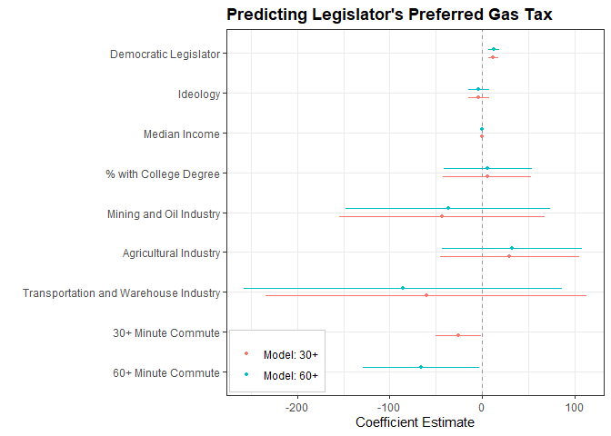
Notes: Coefficient estimates and 95% confidence intervals from regressions of gas tax preferences on legislator and district characteristics. 30+ Minute Commute and 60+ Minute Commute are the proportion of residents with that commute time. 30+ minute commute model, R-squared = 0.32; 60+ minute commute model, R-squared = 0.32; n = 346 for both regressions.
If the relationship between constituents’ commute burden and legislators’ gas tax preferences is driven by the cost of the gas tax for constituents, then we should not observe a relationship between commute time on public transit and support for the gas tax. Those using public transit for their commute should not be sensitive to the gas tax. Instead there should only be a relationship between the commute time of those who drive and the legislator’s gas tax preferences. Consistent with these predictions, Figure 3 shows that longer commute times on public transit are not associated with lower gas tax preferences, whereas longer driving times are (30+ minute drive, p = .06; 60+ minute drive, p =.02; Table 3 in SI). The effect of constituency comes from those who have long drives, not from those who ride public transit. This finding provides further evidence that legislators’ preferences on the gas tax are shaped by how it will impact their constituents who drive their car to work and who would thus be most affected by an increased gas tax.

Figure 3: Placebo Tests Show that Long Public Transit Commutes are not Associated with Lower Gas Tax Preferences.
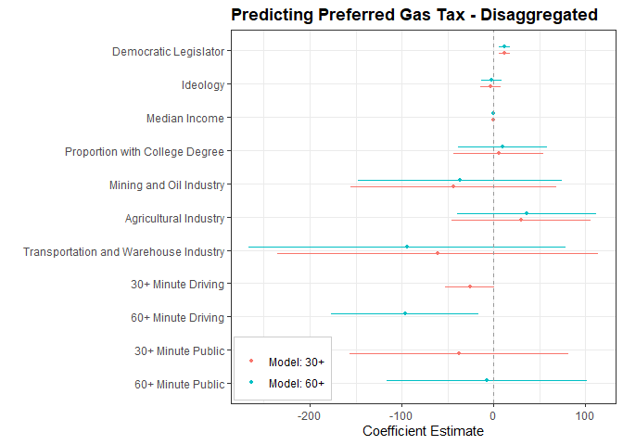
Notes: Coefficient estimates and 95% confidence intervals from a regression of gas tax preferences on legislator and district characteristics. Commute time is disaggregated into commuting by driving and public transit. 30+ minute model, R-squared = 0.32; 60+ minute model, R-squared = 0.32; n = 346 for both regressions.

Results from this unique legislator survey show that the commuting patterns of legislators’ constituents shape legislators’ support for the gas tax. These results focused on the relationship between individual legislators and their district. In order to complement the results at the individual level, we also examine the aggregate relationship between the 2019 gas tax rate (American Petroleum Institute 2019) and the 2015 average annual vehicle miles driven (Department of Transportation, 2015) in each state. This analysis allows us to explore the implications of our individual-level analysis at the aggregate level of the state.
Figure 4 shows that states with more miles driven per year have, on average, lower gas taxes than states with fewer miles driven per year (full results in SI Table 4). The results from the legislator survey showed that there was a relationship at the individual level; Figure 4 shows that this relationship is consequential in the aggregate as well. The preferences of the legislators, derived in part from the commuting behavior of their constituents, appear to shape carbon policy at the state level.

Figure 4: Relationship between Miles Driven per Year and Gas Tax Levels by State. 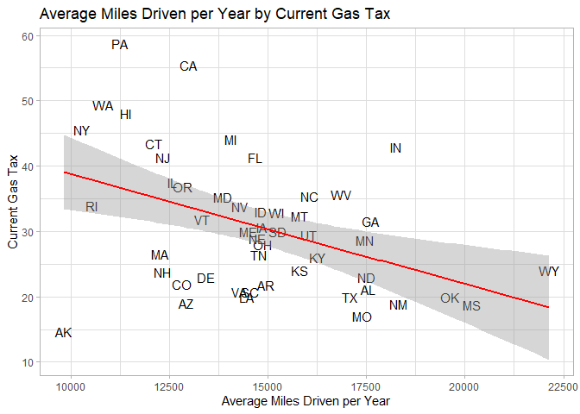
Notes: R-squared = 0.19; n = 50.
Discussion and Conclusion
Our results show that legislators’ positions on policies are responsive to constituents’ interests; specifically, we found that there is a negative correlation between the share of constituents who have long-car commutes and a legislator’s support for a higher gas tax. This finding speaks to the constraints legislators face from the policy interests of their constituents and how changes to the costs and benefits of policies on particular groups can shape the range of policies that legislators can pursue without fear of electoral retribution.
Our findings have practical implications for addressing climate change; analysis suggests that decreasing the number of people who commute by car is likely to provide legislators with the political will power to increase the gas tax, which in turn will reduce carbon emissions. We estimate that if 10% of people with a commute over 60 minutes used public transit instead of their personal vehicle, legislators would prefer a gas tax that is 6.6 cents higher. And a gas tax that is 6.6 cents higher would decrease U.S. carbon emissions by an additional 1% (Davis and Kilian, 2011). In Germany, for example, gas tax increases between 1997 and 2015 were found to substantially reduce vehicle miles traveled (Frondel and Vance 2018). Moreover, research has shown that while Germans are less car-dependent than Americans, car travel demand in the U.S. is more responsive to prices than in Germany, and therefore gas tax increases could have an even greater impact on carbon emissions in the U.S. than in Germany (Buehler 2010).
The finding that longer commute times are associated with less support for the gas tax offers an opportunity for a double dividend from investments in public transit. The expansion of public transit has the potential to both reduce carbon consumption directly (Ercan, Onat, and Tatari 2016; Spiller et al. 2014) and to reduce it indirectly by increasing support for a carbon tax that would have the effect of reducing carbon consumption. That is, investments that shift people from driving to commuting on public transit can reduce carbon emissions from transport and offer legislators the leeway they need to support gas taxes that further reduce carbon consumption.
Some American cities have successfully employed this feedback loop by disincentivizing driving through pricing policies while incentivizing alternative modes of transportation through infrastructure investments. Between 2006 and 2017, transit ridership in Seattle increased by forty-six percent while average daily traffic declined by five percent, despite a twenty-three percent increase in the city’s population (Seattle Department of Transportation 2018). Of Seattle’s $4.6 billion in transportation revenue, eleven percent is collected from the state gas tax, which is set at 49.4 cents/gallon, and twelve percent is collected from drivers through other means such as taxes, car tabs, license fees, and tolls (Gutman and Eng 2018).
Investment in public transit in many states could help to produce a policy feedback (Weaver 2010) that facilitates a change in the status quo by weakening the path dependence (Pierson 2011) produced by constituents with long commutes in cars who undermine legislator support for gas taxes. Rather than being constrained by constituents who commute in cars and would pay the gas tax, legislators would be freer to support increases in the gas tax. Along with reducing carbon consumption, with attendant health co-benefits (Shaw et al., 2014), the gas tax produces revenue for needed alternative transportation infrastructure projects, perhaps even yielding a positive feedback between the gas tax, public transit, and political will for the gas tax.

References
Adler, E. Scott, Adam F. Cayton, and John D. Griffin. 2018. “Representation When Constituent Opinion and District Conditions Collide.” Political Research Quarterly 71(3): 681–94.
Alternative Fuels Data Center. 2018. “Maps and Data - Fuel Taxes by Country.” https://afdc.energy.gov/data/10327 (October 28, 2020).
American Petroleum Institute. 2019. “Notes to State Motor Fuel Excise and Other Taxes.”
Anderson, Sarah E. 2011. “Complex Constituencies: Intense Environmentalists and Representation.” Environmental Politics 20(4): 547–65.
Anderson, Sarah E., Daniel M. Butler, and Laurel Harbridge. 2016. “Legislative Institutions as a Source of Party Leaders’ Influence.” Legislative Studies Quarterly 41(3): 605–31.
Anderson, Sarah E., Daniel M. Butler, and Laurel Harbridge-Yong. 2020. Rejecting Compromise: Legislators’ Fear of Primary Voters. Cambridge University Press.
Anderson, Soren T., Ryan Kellogg, and James M. Sallee. 2013. “What Do Consumers Believe about Future Gasoline Prices?” Journal of Environmental Economics and Management 66(3): 383–403.
Anzia, Sarah F., and Molly C. Jackman. 2013. “Legislative Organization and the Second Face of Power: Evidence from U.S. State Legislatures.” The Journal of Politics 75(01): 210–24.
Ballotpedia. 2014a. Partisan Composition of State Houses. http://ballotpedia.org/Partisan_composition_of_state_houses (July 31, 2014).
———. 2014b. Partisan Composition of State Senates. http://ballotpedia.org/Partisan_composition_of_state_senates.
———. 2014c. State Legislatures with Term Limits. http://ballotpedia.org/State_legislatures_with_term_limits.
Bélanger, Éric, and Bonnie M. Meguid. 2008. “Issue Salience, Issue Ownership, and Issue-Based Vote Choice.” Electoral Studies 27(3): 477–91.
Buehler, Ralph. 2010. “Transport Policies, Automobile Use, and Sustainable Transport: A Comparison of Germany and the United States:” Journal of Planning Education and Research. https://journals.sagepub.com/doi/10.1177/0739456X10366302 (October 28, 2020).
Bussing, Austin, Will Patton, Jason M. Roberts, and Sarah A. Treul. 2020. “The Electoral Consequences of Roll Call Voting: Health Care and the 2018 Election.” Political Behavior. https://doi.org/10.1007/s11109-020-09615-4 (March 3, 2021).
Butler, Daniel M., and David W Nickerson. 2011. “Can Learning Constituency Opinion Affect How Legislators Vote? Results from a Field Experiment.” Quarterly Journal of Political Science 6(1): 55–83.
Cammenga, Janelle. 2020. “How High Are Gas Taxes in Your State?” Tax Foundation. https://taxfoundation.org/state-gas-tax-rates-2020/ (March 3, 2021).
Canes-Wrone, Brandice, David W. Brady, and John F. Cogan. 2002. “Out of Step, Out of Office: Electoral Accountability and House Members’ Voting.” American Political Science Review 96(01): 127–40.
Cromartie, John. 2017. Rural America at a Glance, 2017 Edition. United States Department of Agriculture Economic Research Service. http://www.ers.usda.gov/publications/pub-details/?pubid=85739 (July 17, 2020).
Davis, Lucas W., and Lutz Kilian. 2011. “Estimating the Effect of a Gasoline Tax on Carbon Emissions.” Journal of Applied Econometrics 26(7): 1187–1214.
Decker, Christopher S., and Mark E. Wohar. 2007. “Determinants of State Diesel Fuel Excise Tax Rates: The Political Economy of Fuel Taxation in the United States.” The Annals of Regional Science 41(1): 171–88.
Department of Transportation. 2015. 2015 State Statistical Abstracts - Policy | Federal Highway Administration. https://www.fhwa.dot.gov/policyinformation/statistics/abstracts/2015/ (September 15, 2020).
Dietz, Thomas, Amy Dan, and Rachael Shwom. 2007. “Support for Climate Change Policy: Social Psychological and Social Structural Influences.” Rural Sociology 72(2): 185–214.
Ercan, Tolga, Nuri Cihat Onat, and Omer Tatari. 2016. “Investigating Carbon Footprint Reduction Potential of Public Transportation in United States: A System Dynamics Approach.” Journal of Cleaner Production 133: 1260–76.
Frondel, Manuel, and Colin Vance. 2018. “Drivers’ Response to Fuel Taxes and Efficiency Standards: Evidence from Germany.” Transportation 45(3): 989–1001.
Gutman, David, and Emily Eng. 2018. “Where Is Your King County Transportation Money Going? And What Is It Costing You? These Are the Numbers.” The Seattle Times. https://www.seattletimes.com/seattle-news/transportation/where-is-your-king-county-transportation-money-going-and-what-is-it-costing-you-these-are-the-numbers/ (July 18, 2020).
Harbridge, Laurel, Jon A. Krosnick, and Jeffrey M. Wooldridge. 2016. “Presidential Approval and Gas Prices: Sociotropic or Pocketbook Influence?” In Political Psychology: New Explorations, Taylor and Francis Inc., 246–75. https://www.scholars.northwestern.edu/en/publications/presidential-approval-and-gas-prices-sociotropic-or-pocketbook-in (July 10, 2020).
Healy, Andrew, and Neil Malhotra. 2009. “Myopic Voters and Natural Disaster Policy.” American Political Science Review 103(03): 387–406.
Jackson, John E., and John W. Kingdon. 1992. “Ideology, Interest Group Scores, and Legislative Votes.” American Journal of Political Science 36(3): 805–23.
Kau, James B., and P. H. Rubin. 1982. Congressman, Constituents, and Contributors: An Analysis of Determinants of Roll-Call Voting in the House of Representatives. Springer Science & Business Media.
Klenert, David et al. 2018. “Making Carbon Pricing Work for Citizens.” Nature Climate Change 8(8): 669–77.
Lax, Jeffrey R., and Justin H. Phillips. 2012. “The Democratic Deficit in the States.” American Journal of Political Science 56(1): 148–66.
Levitt, Steven D. 1996. “How Do Senators Vote? Disentangling the Role of Voter Preferences, Party Affiliation, and Senator Ideology.” The American Economic Review 86(3): 425–41.
Lin, Boqiang, and Xuehui Li. 2011. “The Effect of Carbon Tax on per Capita CO2 Emissions.” Energy Policy 39(9): 5137–46.
Lowe, Marcy, Bengu Aytekin, and Gary Gereffi. 2009. “Public Transit Buses: A Green Choice Gets Greener.” In Manufacturing Climate Solutions: Carbon-Reducing Technologies and U.S. Jobs, Duke University, Durham, NC: Center on Globalization, Governance, and Competitiveness.
Marré, Alexander. 2017. Economic Information Bulletin Rural Education at a Glance, 2017 Edition. United States Department of Agriculture, Economic Research Service. https://ideas.repec.org/p/ags/uersib/262133.html (July 17, 2020).
Metcalf, Gilbert E. 2009. “Designing a Carbon Tax to Reduce U.S. Greenhouse Gas Emissions.” Review of Environmental Economics and Policy 3(1): 63–83.
Miller, Warren E., and Donald E. Stokes. 1963. “Constituency Influence in Congress.” American Political Science Review 57(1): 45–56.
Peltzman, Sam. 1984. “Constituent Interest and Congressional Voting.” The Journal of Law & Economics 27(1): 181–210.
Pierson, Paul. 2011. Politics in Time: History, Institutions, and Social Analysis. Princeton University Press.
Rienstra, Sytze A, Piet Rietveld, and Erik T Verhoef. 1999. “The Social Support for Policy Measures in Passenger Transport.: A Statistical Analysis for the Netherlands.” Transportation Research Part D: Transport and Environment 4(3): 181–200.
Rodden, Jonathan A. 2019. Why Cities Lose: The Deep Roots of the Urban-Rural Political Divide. Basic Books.
Seattle Department of Transportation. 2018. 2018 Traffic Report. Seattle Department of Transportation. https://www.seattle.gov/Documents/Departments/SDOT/About/DocumentLibrary/Reports/2018_Traffic_Report.pdf.
Shaw, Caroline, Simon Hales, Philippa Howden-Chapman, and Richard Edwards. 2014. “Health Co-Benefits of Climate Change Mitigation Policies in the Transport Sector.” Nature Climate Change 4(6): 427–33.
Spiller, Elisheba, Heather Stephens, Christopher Timmins, and Allison Smith. 2014. “The Effect of Gasoline Taxes and Public Transit Investments on Driving Patterns.” Environmental and Resource Economics 59(4): 633–57.
Squire, Peverill. 2017. “A Squire Index Update.” State Politics & Policy Quarterly 17(4): 361–71.
Tausanovitch, Chris, and Christopher Warshaw. 2013. “Measuring Constituent Policy Preferences in Congress, State Legislatures, and Cities.” The Journal of Politics 75(2): 330–42.
Thalmann, Philippe. 2004. “The Public Acceptance of Green Taxes: 2 Million Voters Express Their Opinion.” Public Choice 119(1): 179–217.
Weaver, Kent. 2010. “Paths and Forks or Chutes and Ladders?: Negative Feedbacks and Policy Regime Change.” Journal of Public Policy 30(2): 137–62.

Supplemental Information

Appendix A. Representativeness of the Legislative Sample

Our survey sample is broadly representative of the national distribution of state legislators. 27 percent of our sample came from term-limited states compared to 26 percent nationally (Ballotpedia, 2014a), 61 percent of our sample was in the majority party compared to 64 percent nationally, and 81 percent of our sample came from legislatures where the leadership controls committee appointments compared to 83 percent nationally. Although our sample skewed slightly Democratic, 47 percent of our sample were Republicans (compared to 52 percent nationally; Ballotpedia, 2014b, 2014c) and the difference is not statistically significant. The sample is slightly less professional (Squire, 2017) than the average in the population of legislators (mean Squire Index of 0.16 compared to 0.20 nationally) and more of our sample served in legislatures where the majority sets the agenda (74 percent compared to 66 percent nationally; Anzia and Jackman 2013). SI Table 1 compares our sample to national numbers on each of the characteristics discussed above. Our sample’s relatively high degree of representativeness across these characteristics increases our confidence in the generalizability of the findings.

SI Table 1: Comparison of Survey Sample to State Legislator Population
 | % in Sample | % in Population
Female | 27 | 24
Republican | 47 | 52
Term Limits | 27 | 26
In Majority | 61 | 64
Majority Sets Agenda | 74 | 66^
Leadership Controls Committee Assignments | 81 | 83
 | Mean in Sample | Mean in Population
Squire Index | 0.16 | 0.20^
Note: ^ A chi-squared test indicates that the proportion of legislators in our survey serving in a legislature where the majority sets the agenda is significantly greater (at p < .05) than in the population of legislators. A t-test indicates that the mean Squire Index score in the sample is significantly different (at p < .05) than the mean in the population. The Squire index captures how professionalized the legislature is using metrics of legislator pay, days in session and staff resources. For all other attributes, a chi-squared test allows us to reject the null that the distributions are different.

Appendix B. Details on How the American Community Survey Data was Used to Calculate District Measures
We measured median household income, educational attainment, commute time, and employment industry using U.S. census data acquired from the National Historical Geographic Information System (NHGIS), an IPUMS project at the University of Minnesota, which provides census data at many geographic levels including state assembly and senate districts. The data is based on the 2014 American Community Survey (ACS) 5-Year Data [2010-2014].
We use the median household income measure in the ACS, ‘Median Household Income in the Past 12 Months (in 2014 Inflation-Adjusted Dollars)’ (ACS Source code B19013). The educational attainment measure is based on an ordinal categorical variable entitled ‘Educational Attainment for the Population 25 Years and Over’ (ACS Source code B15003) collected in the ACS survey. We calculate educational attainment measure by dividing the number of respondents with at least a bachelor’s degree by the universe of respondents.
The primary commute time measure is based on an ordinal categorical variable titled ‘Travel Time to Work’ (ACS Source code B08303) collected in the ACS survey from the universe of all workers 16 years and over who did not work at home. There are 12 ordinal categories ranging from ‘less than 5 minutes’ to ’90 or more minutes.’ We calculated the primary commute time measure by dividing the number of people with a commute time of 60 or more minutes by the universe of respondents.
Because commuters who drive by private car will feel the impact of a higher gas tax much more than constituents who commute by public transit, we also conduct a follow up analysis that separately estimates the impact of different modes of transportation used for commuting based on a multi-category ordinal categorical variable titled ‘Means of Transportation to Work by Travel Time to Work.’ There are nine ordinal categories for each of the 12 non-exclusive means of transportation ranging from ‘less than 10 minutes’ to ’60 or more minutes.’ We calculated the measures by dividing the number of people with a ’60 or more minutes’ commute in each respective means of transportation (driving and public transit) by the universe of respondents.
Industry proportions are calculated based on the categorical variable ‘Sex by Industry for the Civilian Employed Population 16 Years and Over’ (ACS Source code C24030) collected in the ACS survey (we combined the sex disaggregated categories for our measures). The ‘Mining and Oil Industry’ variable refers to the proportion of people in a legislator’s district working in ‘Agriculture, forestry, fishing and hunting, and mining: Mining, quarrying, and oil and gas extraction.’ The ‘Agricultural Industry’ variable refers to the proportion of people in a legislator’s district working in ‘Agriculture, forestry, fishing and hunting, and mining: Agriculture, forestry, fishing and hunting.’ The ‘Transportation and Warehouse Industry’ variable refers to the proportion of people in a legislator’s district working in ‘Transportation and warehousing, and utilities: Transportation and warehousing.’

Appendix C. Additional Regression Results

SI Table 2: Gas Tax Preferences Predict Vote Choice
 | Yes Vote on Gas Tax Increase
Gas Tax Preference | 0.047***
 | (0.011)
Constant | 0.45***
 | (0.064)
Observations | 58
Log Likelihood | -34.23
Akaike Inf. Crit. | 72.47
Note: Data come from the votes on Wyoming House Bill 69 (in 2013) and New Hampshire Senate Bill 367 (in 2014). The model is estimated using logistic regression. The dependent variable in the model is an indicator variable that takes a value of 1 when the legislator voted to increase the gas tax and 0 when they voted against the gas tax increase. Gas tax preference is operationalized as by taking the absolute difference between the status quo and their final stated preference minus the absolute difference of the proposal and their final stated preference (i.e., |SQ - Preference| - |Proposal - Preference|). This measure takes a positive (negative) value when the proposal (status quo) is closer to the legislators’ survey preference. Thus, a positive coefficient is consistent with the claim that legislators’ stated survey preferences are predictors of their roll call votes. Standard errors in parentheses. * p < 0.1; ** p < 0.05; *** p < 0.01

SI Table 3: Commute Time and Gas Tax Preferences
 | Dependent variable:
 | Preferred Gas Tax
 | 30 Minutes Model | 60 Minutes Model | Median Category Model
 | (1) | (2) | (3)
Democratic Legislator | 11.95*** | 12.41*** | 12.13***
 | (2.96) | (2.96) | (2.95)
Ideology | -3.85 | -3.86 | -3.96
 | (5.60) | (5.60) | (5.59)
Median Income | 0.0002 | 0.0002 | 0.0002*
 | (0.0001) | (0.0001) | (0.0001)
% with College Degree | 5.40 | 5.86 | 5.67
 | (24.36) | (24.39) | (24.16)
Mining and Oil Industry | -43.77 | -37.01 | -56.00
 | (56.55) | (56.46) | (56.95)
Agricultural Industry | 29.66 | 31.91 | 11.42
 | (38.44) | (38.52) | (38.71)
Transportation and Warehouse Industry | -60.445 | -85.65 | -60.06
 | (88.49) | (87.78) | (88.22)
30+ Minute Commute | -25.65**
 | (12.63)
60+ Minute Commute |  | -66.17**
 |  | (32.12)
Median Commute Time |  |  | -3.48**
 |  |  | (1.53)
Constant | 26.77** | 23.06* | 31.55**
 | (12.42) | (12.59) | (12.53)
Observations | 346 | 346 | 346
R² | 0.318 | 0.318 | 0.320
Adjusted R² | 0.197 | 0.197 | 0.199
Note: Full table results for Figure 2. All models include state fixed effects. Model 3 is a robustness check. Dependent variable is the legislator’s stated survey preferences for the level of the gas tax in their state. Models are estimated using ordinary least squares regression. Standard errors in parentheses. * p < 0.1; ** p < 0.05; *** p < 0.01.

SI Table 4: Disaggregated Placebo Test Models
 | Dependent variable:
 | Preferred Gas Tax
 | 30 Minutes Model | 60 Minutes Model
 | (1) | (2)
Democratic Legislator | 11.860*** | 12.010***
 | (2.984) | (2.982)
Ideology | -3.230 | -1.987
 | (5.851) | (5.779)
Median Income | 0.0002 | 0.0002
 | (0.0001) | (0.0001)
% with College Degree | 5.344 | 9.797
 | (24.930) | (24.638)
Mining and Oil Industry | -43.830 | -36.529
 | (57.050) | (56.447)
Agricultural Industry | 30.361 | 36.141
 | (38.664) | (38.659)
Transportation and Warehouse Industry | -60.496 | -94.072
 | (89.065) | (88.021)
30+ Minute Driving | -25.883*
 | (13.660)
30+ Minute Public | -37.657
 | (60.792)
60+ Minute Driving |  | -96.140**
 |  | (40.953)
60+ Minute Public |  | -7.169
 |  | (55.748)
Constant | 27.397** | 23.528*
 | (12.567) | (12.602)
Observations | 346 | 346
R² | 0.318 | 0.321
Adjusted R² | 0.195 | 0.198
Note: Dependent variable is the legislator’s stated survey preferences for the level of the gas tax in their state. Models are estimated using ordinary least squares regression. Standard errors in parentheses. * p < 0.1; ** p < 0.05; *** p < 0.01.

SI Table 5: Gas Taxes and Average Miles Driven
 | Gas Tax in the State
Average Miles Driven | -0.002***
 | (0.001)
Constant | 55.615***
 | (7.627)
Observations | 50
R² | 0.186
Adjusted R² | 0.169
Note: Dependent variable is the gas tax in a state. Model is estimated using ordinary least squares regression. Standard errors in parentheses. * p < 0.1; ** p < 0.05; *** p < 0.01.

These respondents had the opportunity to type in their preferred tax above the 150 range on the slider.
The preferences of nonpartisan legislators in Nebraska are captured by the state fixed effect.

