Who Wins: Party Control and Policy Responsiveness
G. Agustin Markarian
Loyola University Chicago (corresponding author)
Assistant Professor
gmarkarian@luc.edu
(310)774-6873

Jacob S. Hacker
Yale University
Professor
jacob.hacker@yale.edu

Zoltan Hajnal
U.C. San Diego
Professor
zhajnal@ucsd.edu

Mackenzie Lockhart
Yale University
Post-doc
mackenzie.lockhart@yale.edu
July 30, 2025
Word count: ~11,980 Including tables & figures.
Abstract:
Who wins and loses on national policy issues? Political scientists have put forward three competing accounts that emphasize, alternately, the persistent influence of advantaged groups, the importance of the median voter, or the rising dominance of partisan loyalists. Each of these three traditions highlights a distinct source of influence and offers a distinct prediction about who wins and loses. In this paper, we assess the contrasting expectations of these theories using a new approach that examines the role of multiple individual voter characteristics alongside party control of government. To do so, we link national policy outcomes over a nearly twenty-year recent period to over 500,000 responses from the Cooperative Election Study on 134 salient bills. Averaged over time, disparities across social groups appear muted. But this masks a deeper pattern: policy responsiveness shifts dramatically with partisan control. Under Republican governance, White, wealthy, male, and Evangelical Americans are more likely to see their preferences enacted than their counterparts. Under Democrats, responsiveness favors Black, secular, and college-educated Americans and religious minorities. In both cases, policy winners are electoral loyalists of the party in power. These findings challenge both the idea of stable group-based privilege and the median voter model. Instead, we reveal a pattern of conditional representational disparities, where partisan control powerfully shapes who wins and loses. In an era of heightened polarization, the aims and electorates of the parties look very different, and so too do the groups that get what they want under each.
Who wins and who loses on national policy issues? Political scientists have long sought to answer this fundamental question. Yet they have reached conflicting conclusions, in part because they focus on different elements of representation. On the one hand, a large body of research has examined whether certain groups of citizens—for example, the affluent—have more sway over policy than others. Though marked by continuing dispute (Enns 2015; Soroka and Wlezien 2008; Branham et al. 2017; Clifford 2012), this scholarship has suggested that policy is less responsive to groups with socioeconomic and status disadvantages, including working-class citizens (Gilens and Page 2014; Bartels 2008), racial and ethnic minorities (Griffin et al. 2019; Butler and Broockman 2014; Hero 1992), women (Griffin, Newman, and Wolbrecht 2012; Stephanopoulos 2015; Mathisen 2024), and the young (Griffin and Newman 2008).
On the other hand, seminal literature focused on electoral incentives proposes that unequal responsiveness emerges from rational moderating behavior in two-party elections. The classic view—expressed succinctly in the median voter theorem—is that those in the middle receive the most attention and thus are likely to hold the greatest sway over policy (Downs 1957; Erikson et al. 1993). This median voter perspective holds that electoral significance, rather than group size, status, or resources, determines policy influence. As such, moderate and swing-voting blocs enjoy a privileged position in national policymaking, while groups more loyal to one party are sidelined (Downs 1957; Frymer 1999; Erikson et al. 1993; Hajnal and Lee 2011).
Rising party polarization in American politics has encouraged a third, very different perspective. New work has argued that parties in power respond not to ideological moderates but to coalitions of highly engaged activists and interest groups (Bawn et al. 2012)—a position made plausible by the growing policy distance between the parties, as well as the greater tendency of voters to stick with their own party at the ballot box. Rather than focusing on privileged or pivotal voters, this perspective centers parties, and especially party loyalists, as the primary drivers of representation and policy outcomes (Maks-Solomon and Rigby 2019; Lax et al. 2019).
These traditions—one emphasizing social group power, the other two focusing on electoral incentives—have largely evolved along separate tracks. Yet they offer fundamentally different accounts of representation. Either policy is disproportionately shaped by socially and economically advantaged groups, or it is driven by the preferences of electorally pivotal moderates, or it is centered on the demands of core partisans. It is hard to imagine a world where all can be true at the same time. Yet we lack systematic studies that try to assess simultaneously the extent to which each of these three sets of actors—well-resourced voting blocs, centrist voting blocs, and party loyalists—are (or are not) representationally privileged. We have theories that explain why some privileged groups might be systematically favored, and we have theories that explain why parties might prioritize swing voters or instead cater to their core supporters. What we lack is work that considers how differential responsiveness to social groups and to partisan constituencies jointly shape national policymaking. As a result, we remain farther than we should from a full understanding of who wins and who loses in American democracy.
In this paper we seek to move closer to that understanding. Building on studies of unequal influence, we examine the congruence between the preferences of different groups of citizens and national policy outcomes—a common definition of policy responsiveness. Building on studies of partisan lawmaking, we then examine how policy responsiveness so defined varies with shifting party control of Congress and the presidency. Finally, to tie these two sides of our analysis together, we investigate the partisan leanings of the different groups included in our models—that is, how closely aligned electorally each group is with one or the other party. Taken together, these interwoven elements of our analysis—which have not been combined in previous work—allow us to assess not just which groups win or lose, but how that changes based on shifting patterns of party control and the partisan allegiance of different demographic voting blocs.
Two aspects of our approach require emphasis. First, we consider simultaneously a wide range of potentially relevant social cleavages, not just the class divisions that are the focus of much recent work. The two parties today are divided along multiple demographic lines, so understanding the role of parties in shaping policy responsiveness requires a multivariate approach, sensitive to the manifold overlapping group sources of voter partisanship.
Second, we focus on overall policy responsiveness under different configurations of party control. Many studies focus on interim stages of the policy process, such as whether legislators vote in line with constituents’ preferences. Though important, this type of analysis cannot tell us whether ultimate policy outcomes reflect the views of particular groups. And while it can tell us whether politicians side with their co-partisan constituents individually, it cannot answer the question of whether parties as collective entities deliver for some groups versus others when they have power.
These distinctive aspects of our approach require data that allow us to look at multiple demographic cleavages simultaneously and assess overall responsiveness across the long span of lawmaking necessary to examine shifting patterns of party control. To create such a dataset, we combine survey data from the Cooperative Election Study (CES) with our own coding of policy outcomes (that is, a bill becoming law or not) on a large set of salient legislative items. The resulting dataset spans nearly two decades, covers 134 high-profile policy items, and includes responses from over 520,000 Americans.
With these data, we can assess whether CES respondents supported specific legislative items, rather than relying on a latent ideology dimension that may only loosely connect to actual policy positions (Broockman 2016). Because of the large number of respondents, we are also able to examine simultaneously how multiple respondent characteristics—class, race, age, gender, and religion—affect the congruence between preferences and policy outcomes. Importantly, the size of the dataset allows us to assess responsiveness at the individual level, assessing congruence for each constituent separately based on personal characteristics, rather than aggregating preferences to the group level, as is the norm in the literature (e.g., Gilens 2012; Gilens & Page 2014; Stephanopoulos 2015)). Finally, the nearly twenty-year period we analyze includes frequent alternations in party control across the House, Senate, and Presidency, allowing us to assess how responsiveness to different voter groups changes when party control shifts.
Our analysis of this rich dataset produces three key findings. The first is that averaged over the contemporary period of oscillating party control, the representational gaps most discussed in existing studies of group-based advantages, such as between income groups, appear surprisingly muted. When multiple group identities are included in multivariate models, we find limited disparities in responsiveness across most groups. Older Americans get what they want somewhat more often than young Americans but except for disparities based on age, differences are relatively small and not statistically significant.
We caution against interpreting this finding as indicating that American democracy is highly equitable. By design, our dataset is focused on high-profile, controversial issues during America’s recent partisan era. We do not claim, nor would we expect, that the same patterns of responsiveness would emerge on less salient or conflictual issues, in other venues, or during periods in which partisan divisions were more muted (Schattschneider 1960; Culpepper 2010; Hacker et al 2022).
More important for this study, these are average results, and the averages hide our second main finding: gaps that are associated with party control are large. When we analyze our data by partisan control (of the presidency, Congress, or both), representational patterns shift dramatically. Under Republican control, higher-income earners, White Americans, men, and Evangelical Christians experience greater responsiveness than other groups. Under Democratic control, Americans with more formal education, Black Americans, older adults, and religious minorities experience greater responsiveness. The lack of gaps on average are a result of the frequent power shifts that produce shifting disparities and not an equally responsive system.
These party-control-linked disparities bring us to our third main finding: differences in responsiveness under each party closely track the demographics of its most loyal supporters. When parties have control of lawmaking, they do not appear to cater primarily to the preferences of swing voters but instead appear to prioritize the preferences of their core electoral coalitions. This challenges the expectation of the median voter theory and suggests that, at least on high-profile legislative issues, parties have strong incentives to respond to their most loyal voters or at least the activist groups aligned with them (Bawn et al. 2012).
The normative implications of our findings are complex. A world in which winners vary, and no one group loses consistently over time may seem obviously better than one in which both parties overrepresent privileged groups. But the ultimate consequences depend on how fluid party control is, and how much parties can actually accomplish given partisan polarization. It also depends on the extent to which the average balance we find hides deeper partisan asymmetries that structure political inclusion and exclusion—asymmetries that may not be as evident on the high-profile issuers we analyze.
What we can say is that as party control shifts, different groups gain or lose influence. This dynamic may broaden responsiveness over time, particularly for groups like Black Americans who struggle to gain influence in a median voter-driven model (Frymer 1999). But it also creates the potential for volatility, inequality, and policy instability—especially when one’s preferred party is out of power. If policy changes are durable, the consequences of representational exclusion may be lasting. And when partisan gridlock prevents action, even core constituencies may find their preferences unfulfilled.
The remainder of this paper proceeds as follows. First, we outline our theoretical framework, explaining why party control and multiple demographic cleavages must be considered jointly. We then introduce our methodological approach and the distinctive data we use. Next, we present our findings, showing that (1) many representational gaps are muted on average, (2) party control produces large shifts in who wins and loses, and (3) these shifts align with the preferences of the governing party’s most loyal voters. We conclude by discussing some of the potential implications of our findings for how we understand representation in contemporary American politics.
Representation in American Democracy
The public lies at the heart of the democratic process. What government does (or does not do) should reflect, at least in part, the views of the public. The ideal of political equality holds that each member of the public should have an equal opportunity to influence government actions, and no segment of society should have disproportionate sway over policy. There will be winners and losers in any policy conflict. But if those who lose tend to lose consistently across a range of policy areas and across a long-time frame, then concerns about fairness and exclusion emerge.
How does American democracy fare on these standards? Early seminal work focused on how much the public as a whole influences policy, finding that legislators' votes were often correlated with the preferences of their constituents (Miller and Stokes 1963). Similarly, Stimson, Mackuen, and Erickson (1995) showed that shifts in national policy often followed shifts in public opinion (see also Page and Shapiro 1992). According to Caughey and Warshaw (2017), such “dynamic representation” has also characterized policymaking at the state level. Collectively, these studies suggest that American democracy is highly responsive, at least to popular majorities.
Yet many concerns remain about these metrics of responsiveness. Lax and Phillips (2011) paint a very different portrait of state-level policy congruence in which majority opinion matches policy outcomes only about half the time (see also Grumbach 2022). In the same vein, recent work by Ansolabahere and Kuriwaki (2024) finds that congressional action is consistent with majority opinion barely more than half the time. These differing assessments make it difficult to draw definitive conclusions about how well American government represents the interests of the public. More important, these studies examine responsiveness in the aggregate and fail to assess whether different portions of the citizenry are better represented than others and under what conditions.
Inequality in Representation and Responsiveness
Recent research has taken a more nuanced approach, shifting scholars’ gaze from representation of the public as a whole to the relative influence of different segments of the population. This work has focused on unequal responsiveness: Are the wealthy more influential than the working class? Do elected officials devalue or discriminate against the opinions of racial and ethnic minorities? How do factors like age, gender, and religion shape political representation and influence?
The best-known of these studies highlight income differences. Gilens (2005, 2012), Bartels (2008), and Jacobs and Page (2005) have found stark class-based inequalities in national policymaking, with the preferences of middle-income and poor Americans largely ignored while the preferences of affluent Americans drive policy. Other research has found comparable class-based disparities at the state level (Stephanopoulos 2015; Flavin 2012; Rigby and Wright 2011).
Not all scholars agree with this verdict. Some argue that class inequalities are minimal: working and middle-class Americans generally agree with upper-class Americans on most policy issues, move in the same direction when their policy preferences change, and may win even when they disagree with the affluent (Enns 2015; Soroka and Wlezien 2008; Soroka and Wlezien 2010; Ura and Ellis 2008). Other scholars emphasize that interest groups (and parties) are more fundamental than economic classes within the electorate in shaping responsiveness (Grossman et al 2021). Nevertheless, it is broadly accepted that class bias is a central feature of Americans politics. According to this view, economically advantaged Americans are representationally advantaged too.
Other sources of unequal responsiveness are less studied. Given its central role in shaping policy views and driving party identification, race has received the most attention after class. A substantial body of work has documented racial inequities in important aspects of representation. Butler and Broockman (2011), for example, find clear evidence of racial discrimination in the extent to which elected officials responded to constituent queries. Similar discrimination has been documented against minority candidates running for office (Broockman and Saltos 2020; Lajevardi 2020; Visalvanich 2017). Griffin and Newman (2007, 2008) and Griffin et al. (2019) provide evidence that both representatives’ actions and federal policy outcomes are more responsive to the preferences of White Americans than to those of Black and Latino Americans.
Other key voter characteristics such as age and gender have garnered less attention, although a handful of studies have found that men and older Americans wield more influence than women and young Americans (Stephanopoulos 2015; Griffin, Newman, and Wolbrecht 2012; Mathisen 2024; Ellis 2012). Religion, on the other hand, has not been thoroughly studied, with the only relevant analysis we could unearth suggesting limited disparities (Stephanopoulos 2015).
Concerns about a Single Cleavage Framework
Although existing work has greatly increased our understanding of unequal responsiveness, it remains limited in two important respects. First, as just noted, research to date has tended to focus on a single cleavage while ignoring others. For instance, studies that analyze class disparities—the dominant focus—overlook racial ones (Gilens and Page 2014; Bartels 2008). The same criticism can be levied at scholarship on race and responsiveness, although this work has started to move toward a more multidimensional approach (Griffin et al. 2019; Stephanopoulos 2015).
Although this single-cleavage approach has provided seminal insights, it misses the extent to which citizens’ today are split along multiple lines. More so than in previous decades for which we have survey evidence (Zacher 2023), Americans are not divided by income and income alone. They are simultaneously divided by income, education, race, gender, religion, urbanicity, and other factors (Sides, Tausanovitch, and Vavreck 2022, Hajnal 2020). Indeed, for much of the recent period, divisions in the vote by class have been dwarfed by divisions by race (Hajnal 2020). Gaps by gender, religion, age, and urbanicity are also considerable and at times rival class (National Exit Poll 2024; Sides, Tausanovitch, and Vavreck 2022; Hajnal 2020).
Since these different demographic divisions do not merely overlap but are often correlated, analysis that considers one without simultaneously considering the others may lead to an incomplete or inaccurate assessment. Affluent Americans may be advantaged in the policy world because of their greater income and the power associated with it (Gilens and Page 2014; Bartels 2008). But they may also be advantaged by being White, Christian, male, older, or more educated—characteristics that are correlated with income. As a result, focusing on single cleavages likely provides an incomplete picture of how individual characteristics shape who wins and who loses in national lawmaking. While some recent research has begun to explore these complexities (e.g., Stephanopoulos 2015), much remains to be done to integrate multiple cleavages into empirical analyses of who gets represented.
Parties and Inequality in Responsiveness
This brings us to the second major limitation of existing work: its generally limited attention to the role of parties. Studies of democracy have long highlighted the incentives of parties and party leaders to favor some segments of the public over others. Yet these arguments are, at present, poorly integrated into scholarship on unequal responsiveness (e.g., Gilens 2005; Gilens and Page 2010; Stephanopoulos 2015; Griffin et al. 2019; Mathisen 2024).
Though a small subset of studies has asked whether party is associated with class disparities in representation, these analyses have largely focused on representatives’ roll-call votes, not policy outcomes, and even here reaches differing conclusions (Maks-Solomon and Rigby 2019; Lax et al. 2019). Studies that look beyond the roll-call vote still focus on representatives’ behavior. Grossman et al. (2021), building off Gilens’s data, concludes that Democratic leaders express positions aligned with the views of middle class-oriented advocacy groups while Republican leaders align with the preferences of business groups. Similarly, Rhodes and Schaffner (2017) find that the relationship between district income and the ideology of House members is positive for elected Republicans but flat or negative for Democrats. A few studies also consider related factors such as the size of a party’s majority or overall polarization (e.g., Gilens 2012)
These valuable studies suggest that party control matters. But they do not say how it matters for policy outcomes. As important as it is to know how well voter preferences align with their representatives’ roll call votes or rhetoric, such “dyadic” representation is not the same as overall policy responsiveness. For example, a legislator might consistently vote in line with a majority of their Black constituents’ preferences—yet if their priorities are never enacted, they are still losing on policy. Conversely, a group might see its preferences become law even if its own representative opposed the measure. Thus, dyadic representation is not a reliable proxy for who ultimately wins or loses in the policymaking process. To assess the quality of representation, we also need to know who wins or loses on policy outcomes—a metric that citizens care deeply about too (Ansolabahere and Kuriwaki 2021).
Nor do these studies look at the role of race, gender, education, age, or religion. There are a handful of analyses of how party control affect the representation of women and racial minorities that suggest that Democratic party control results in greater congruence (Griffin and Newman 2009; Griffin, Newman, and Wolbrecht 2012). However, these analyses look at a narrow subset of issues; rely on broad ideology measures; do not consider the simultaneous role of other demographic characteristics, including income; or, again, focus on roll-call votes, not policy outcomes.
The limited attention to parties in the literature on unequal influence reflects multiple factors. Foundational studies of political inequality often do not center parties in part because they assume that both major parties are subject to similar structural pressures: disparities in campaign financing patterns (Gilens 2012; Bonica and Grumbach 2022), biases in legislators’ worldviews (Butler 2014; Gilens 2012), lobbying and interest group capture (Baumgartner et al. 2009), institutional racism (Hajnal 2009; Griffin and Newman 2008), and other forces that constrain responsiveness regardless of which party is in power. From this perspective, partisan control may matter less than the shared incentives and biases that shape elite behavior across the board.
Similarly, median voter models do not predict large shifts in policy based on which party governs. Instead, they suggest that both parties will converge around centrist positions to maximize electoral support (Downs 1957). Yet this logic sits uneasily with research on political inequality and representation, which finds not only limited responsiveness to majority opinion, but also systematic differences in responsiveness across income, race, and other group-based cleavages. Some extensions of the median voter model have attempted to explain biases in representation—arguing, for example, that parties may neglect loyal partisan groups like Black voters because these voters are unlikely to defect to the opposition (e.g., Frymer 1999). But this rationale conflicts with other core insights of the political inequality literature: if the system is centered on the preferences of the median voter, why would the exceptionally wealthy wield exceptional political power?
The logic of median voter theories and party-agnostic inequality theories are increasingly difficult to reconcile with contemporary conditions. In a highly polarized environment where parties rely on core supporters to fund and activate campaigns and turnout is seen as crucial, incentives to move to the middle may be outweighed by incentives to mobilize the base (Bawn et al 2012). Moreover, the rise of safe seats has increased the importance of primaries (Cowburn 2024), reinforcing the sway of the more extreme voters who are most likely to turn out for these in-party contests (Hassell 2018).
The “UCLA School” of party behavior emphasizes that parties are best understood as coalitions of intense demanders—interest groups, activists, and core voting blocs that provide financial and other resources, activist energy, and organizational capacity (Bawn et al. 2012). For parties to maintain these coalitions, they must demonstrate responsiveness to their most engaged and reliable supporters, even when doing so entails diverging from the preferences of median voters. For these scholars, party messaging, policy design, alternative media ecosystems, and motivated reasoning all enlarge the “electoral blind spot” in which parties can act without fearing backlash from swing voters (Bawn et al 2012; Achen and Bartels 2016; Levendusky 2013). If these dynamics dominate, we should expect representation to favor the party’s base when it governs, rather than swing voters.
Methodological challenges have also hindered the integration of these two traditions of scholarship. One challenge is that the parties are divided along multiple lines—not just by class, but also by race, ethnicity, age, gender, and religion. More so than in the past, America’s two major parties offer distinct and polarized policy agendas not just on economic issues, but on social and cultural issues where race, gender, age, education, and religion sharply divide public opinion. For this reason, the single-cleavage approach dominant within studies of unequal influence is ill-suited to assessing whether parties are responsive to their more loyal supporters.
Other methodological challenges also discourage consideration of the role of party control. One we have already noted is that studies need to examine ultimate policy outcomes, not just roll-call votes, to assess the impact of parties as collective actors. Another is that many studies do not cover a period long enough and with enough changes in party control to reliably examine the relationship between responsiveness to different groups and which party controls the presidency, Congress, or both. To date, no study has analyzed the effect of party control on unequal responsiveness in U.S. national policymaking across a broad set demographic characteristic and long period of contemporary lawmaking. In a context of heightened polarization and distinct party coalitions, we argue this omission limits our understanding of how democratic responsiveness functions today.
Party Power and Unequal Representation: A New Empirical Strategy
Our approach aims to address the limits of prior studies and bridge work on party behavior and studies of unequal influence. To do so, we combine data covering a long recent time span in which party control has changed frequently with multivariate analysis of multiple cleavages within the electorate. These data allow us to examine which groups of voters win and lose on policy, how that changes when party control of the presidency and Congress shifts, and whether these patterns of differential responsiveness suggest that parties in power are more or less responsive to groups of voters based on their electoral loyalty.
Leveraging the Cooperative Election Study to Examine Party-Based Responsiveness
Our primary data source is the Cooperative Election Study, available publicly since 2006 and running through 2022 in our analysis. The largest politics-focused survey in the United State, the CES is an extensive, annual survey conducted by YouGov (Ansolabehere and Schaffner 2014). Sample sizes range from approximately 8,000 to 60,000 respondents each year. The survey targets the eligible voter population, not the national population, and reflects the demographic diversity of the electorate, as detailed in SI-A.
The CES annually includes four to ten questions related to specific roll-call votes in Congress, either recently conducted or anticipated. These questions ask respondents how they want their Members of Congress to vote on key issues. The CES items are not designed to represent all bills or public concerns. Instead, they focus on high-profile national issues from 2003 to 2022, such as minimum wage increases, the Affordable Care Act, abortion restrictions, military withdrawal from Iraq, and responses to the COVID-19 pandemic. While a broader set of questions would be ideal, we consider these items critical for assessing responsiveness. If representation is not observed on them, it is unlikely to be present on less salient ones. Still, we caution against assuming similar responsiveness in the national lawmaking process on lower-profile issues.
The CES covers 140 items, some recurring across multiple years, including six nominations for the Supreme Court and agency heads, which we remove from our main analysis (robustness tests including nominations are available in SI-B). We hand-matched each of the remaining 134 items to the relevant legislation. We were able to match 111 to specific legislation with a roll call vote taken on the floor of at least one chamber of Congress. In all cases, we match to the bill voted on temporally closest to when the CES asked about an issue.
In the SI-C, we compare these 111 bills with all bills, public laws, and the Congressional Quarterly Almanac, from which the CES list is partly drawn (Ansolabehere and Kuriwaki n.d.). These comparisons show that the CES closely aligns with broader measures of the congressional agenda. We further compare the CES questions with Mayhew’s “important enactments” and Curry and Lee’s “congressional majority party agenda” bills. A large share of the bills identified by Mayhew and many discussed by Curry and Lee are in the CES. In sum, the CES covers a diverse set of bills that encompass a sizable share of the most important domestic and foreign issues that Congress considers.
Advantages of the CES for Our Study
The CES has several advantages for our purposes. First, unlike in most previous research, we do not have to rely on ideological scales to assess congruence (i.e., how liberal a member of Congress is relative to their constituents), nor do we have to make difficult decisions about whether specific policy outcomes are responsive (or not) to general policy questions asked in less carefully designed surveys. We can match exactly respondents’ yes-no preferences to policy outcomes. In all, we have approximately 3.5 million responses from over 520,000 Americans across nearly two decades, encompassing periods of both Democratic and Republican control of Congress and the presidency.
A second advantage of our dataset is that the large number of respondents allows us to systematically examine how multiple demographic factors—class, race, age, gender, and religion—shape representation at the individual level. The CES includes detailed information on these characteristics for all respondents across all years of the CES (geographic location, which we analyze in SI-D, is only collected during some years). Most extant research, by contrast, is aggregated to binary indicators at the group level (e.g., Gilens and Page 2014, Gilens 2012; Stephanopoulos 2015). This largely precludes multivariate analysis, especially when the average positions of different groups are highly correlated with the average positions of other groups. By contrast, we are able to examine the relationship between each voter’s varying demographic characteristics and whether that voter wins on a policy issue.
Finally, our data allows us to examine a contemporary period in which party control has changed frequently. Ansolabehere and Kuriwaki (2024) use the same CES data we draw on but focus on responsiveness to majority opinion, rather than disparities in responsiveness across groups. Gilens’s now-famous dataset, by contrast, ends roughly two decades ago. Heightened polarization since then is likely to have increased the effect of party control. While our dataset does not offer the breadth and variety of policies in Gilens and Page (2014), it does provide a cleaner match between policy questions and outcomes as well as a larger sample for each policy analyzed, allowing us to simultaneously explore multiple cleavages at the individual level.
Measuring Overall Policy Responsiveness
Our measure of representation focuses on whether individuals’ preferences align with actual policy outcomes on salient legislation. While some theories emphasize thresholds of majority support or incremental responsiveness over time, we follow a long line of research—including Gilens and Page’s seminal study (2014)—in treating preference-outcome congruence as a meaningful indicator of representation. This allows us to directly assess whether individuals “win” or “lose” on policies that reach the national agenda—an outcome citizens care about regardless of whether they win due to intentional responsiveness or coincidental alignment.
Of course, what makes it onto the legislative agenda is itself an element of responsiveness—shaped not just by popular demands or rank-and-file input, but especially by congressional leaders, who have considerable power to determine what reaches the floor. This means, among other things, that the CES items are more likely to divide the parties. While such agenda control contributes to the party-based disparities we observe, it is also a defining feature of contemporary policymaking that analyses of representation must capture. As the parties have polarized, the incentive to use majority power to pass policies preferred by the party in power has increased. The question is who wins and who loses when those partisan policies are enacted—or fall short.
We include all policy items in our analysis rather than restrict to those with large group differences. Limiting analysis to divisive issues can generate misleading inferences (Enns 2025), while excluding many relevant policy items. Importantly, preference divergence across key demographic groups is substantial in our data: average absolute policy preference gaps are 14.7 percentage points between Black and White respondents, 8.6 points between men and women, 10.2 points between those with and without a college degree, 8.6 points between high- and low-income individuals, and 21 points between Evangelicals and the non-religious. These sizeable differences ensure that any disparities we observe in responsiveness are largely driven by policies where group preferences diverge—precisely the conditions under which unequal representation is most consequential.
Policy responsiveness is not the only relevant measure of democratic performance, nor does it capture all forms of representation. Still, whether some citizens get more of what they want from lawmaking than others is an important metric of democratic equality that has occasioned an outpouring of scholarship. By leveraging an extended time frame, individual-level data, and a multi-cleavage approach that centers party control as a critical mediator of responsiveness, we provide a new—and we believe fuller—answer to this fundamental question.
In answering this question, our goal is to show how responsiveness varies across groups based on party control of government. Our findings strongly suggest that party control matters for who wins and who loses, though several alternative causal mechanisms might produce the differences in preference-policy congruence we find. Our aim is to provide a solid empirical picture of disparities in responsiveness, not to pinpoint the mechanisms underpinning them—mechanisms we hope future studies will examine more closely.
Findings: Limited Aggregate Gaps but Substantial Variation by Party Control
Overall, our data suggests that federal policy is not particularly responsive to public preferences. Aggregate responsiveness hovers just below 50 percent, indicating that on average, policy outcomes align with public preferences less than half the time. This suggests lackluster policy responsiveness overall, similar to the relatively low levels of congruences or responsiveness found in other studies (Lax and Philips 2012; Griffin et al. 2019; Ansolabahere and Kuriwaki 2024).
Pooled Differences in Responsiveness Across Groups
These aggregate rates could, however, hide significant variation in representation across different groups. To measure such disparities, as discussed, we stratify preferences by income, race, education, age, gender, and religion (and, in SI-D, urban-rural residence). Our models include policy question-fixed effects to account for year-to-year differences in the CES, electoral cycles, and baseline differences in legislation popularity. The coefficients reveal average deviations in representation within-bills as a result. Models used CES-created common content weights to reduce sampling bias. Our models are specified as follows:
OutcomeMatch_i,v = Income_i + Race_i + Gender_i + Education_i + Religion_i + Age_i + QuestionFE + epsilon_i,v
Results are presented in Figure 1 and full model results are available in SI-E. The vertical dashed line at zero serves as a reference point, with coefficients to the right suggesting higher policy win rates and those to the left indicating lower rates.
Figure 1: Multivariate Analysis of Aggregate Win Rates
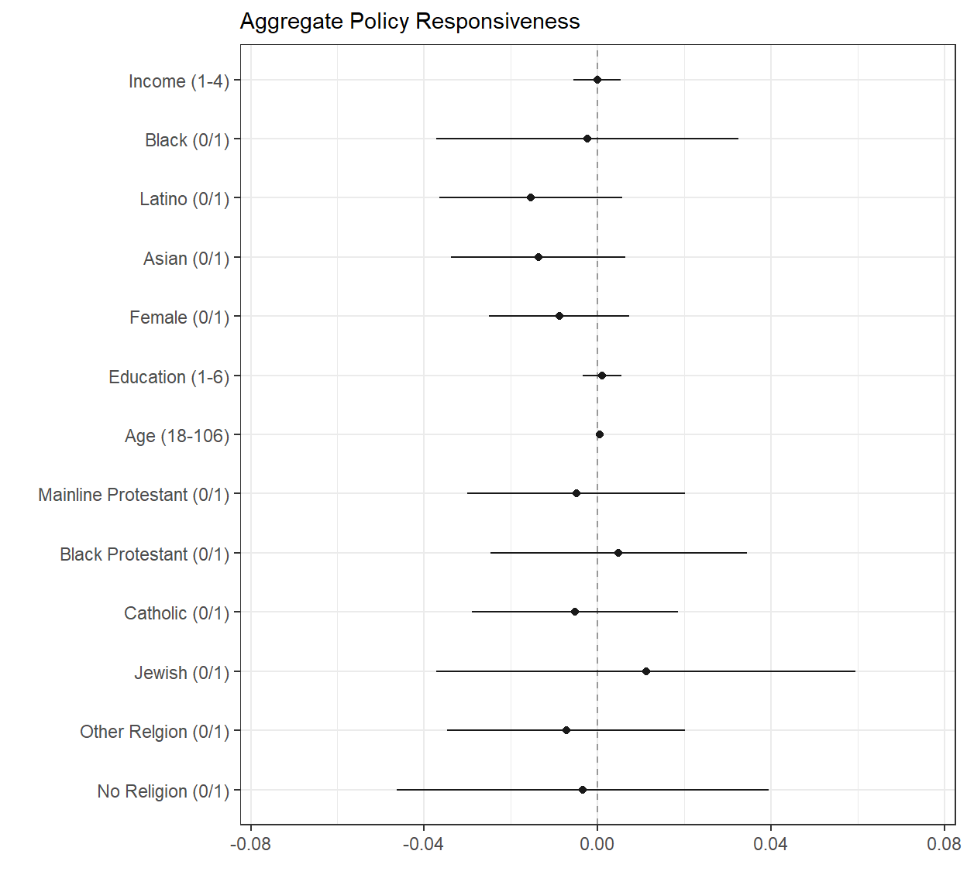 Note: Income is measured on a 4-point ordinal scale (1 = Less than $29,999, 2 = $30,000-69,999, 3 = $70,000 – 149,999, 4 = More than $150,000). Racial groups are binary indicators and “White” is the reference category. Female is a binary indicator and “male” is the reference category. Education is measured on a 6-point scale (1 = Did not graduate high school, 2 = High school graduate, 3 = Some college (but no B.A.), 4 = 2-year college degree, 5 = 4-year college degree, 6 = Postgraduate degree). Age is a continuous variable. Religions are binary indicators and “Evangelical Protestant” is the excluded category. All models use CES question fixed effects and cluster-standard errors. Models use CES common content weights. Full model results are available in SI-E.

The most notable finding depicted in the plot is that policy responsiveness is relatively even. Across this entire period, few demographic groups win significantly more than others, the magnitudes of the differences are substantively small, and the standard errors allow us to rule out even moderately sized disparities. At least by this metric over this extended interval of lawmaking, policy representation appears open to different segments of the population.
Starting with class, the figure reveals no significant differences in representation by income (modeled using a four-point ordinal scale) or education (measured on a six-point ordinal scale). Americans with higher incomes (or more education) are not significantly more likely to have their views reflected in national policy outcomes than Americans with lower incomes (or less education). This comes as a surprise given the numerous studies that suggest U.S. national policymaking is biased in favor of the rich (Gilens 2005; 2012; Gilens and Page 2014; Bartels 2008).
Similarly, we find no substantial or significant differences in representation by race. Over the entire period, neither African Americans, Latinos, nor Asian Americans experience significantly different levels of representation than White Americans (who are the excluded category in the model). Again, this contrasts with some of the previous work on race that finds more consistent and substantial differences in representation across racial groups (Griffin et al. 2019; Stephanopoulos 2015; Butler and Broockman 2014; Griffin and Newman 2008; Hero 1992).
The model also reveals no significant representational disparities by gender or religion. The coefficient for the “female” coefficient is not statistically significant. The religious affiliations, defined by Pew’s religious tradition (“RELTRAD”) coding, are also not associated with representational advantages or disadvantages (Steensland et al. 2000). Most coefficients are near zero, with wide confidence intervals, suggesting policy is equally responsive to Evangelical Protestants (the excluded category in the model), Mainline Protestants, Black Protestants, Catholics, Jews, people of other religious identities, and the non-religious.
In robustness test in SI-D, we investigate the effects of rural versus urban residency (we do not include these test in the main model because of incomplete data). Despite considerable discussions on the relative advantages of rural Americans in the democratic process, we find that residents of rural places do not have more influence over policy than residents of urban places.
We do find modest differences in responsiveness across lines of age. While difficult to see given then range, Figure 1 indicates older individuals have slightly higher policy win rates when controlling for demographic correlates. The model suggests that a 68-year-old individual wins on policy about 2.8 percentage points more often than an 18-year-old individual. While the gap is statistically significant, it is relatively small in magnitude.
In short, a look at representation over this nearly two-decade period suggests that federal policymaking is relatively balanced. With the exception of the young and Asian Americans, few segments of the population appear clearly underrepresented, and even for these distinctively disadvantaged groups, the deficit is small.

Variation in Responsiveness Over Time
How can we understand these potentially surprising findings? Why might representational disparities appear muted over our nearly two-decade period? The differences between our results and those of some previous studies could be due to a number of factors including the focus on salient legislative issues or the more recent time period that we study. The patterns of results are not due to our using a multivariate rather than bivariate approach. Bivariate results, presented in SI-G, reveal a similar pattern. Aggregate win rates vary only slightly across the groups. For almost all groups aggregate win rates are below 50 percent. Our findings are also not obviously due to a particular set of issues. Even when we subset our data by broad issue areas in SI-H, we find limited or non-existent gaps across groups.
The most relevant factor may be time. Not only are we looking at a more recent period than covered by classic studies; in addition, our initial multivariate analysis pools the results for our entire time series Our theory-driven focus on partisan control, however, implies that which party controls government—and especially the presidency—should systematically shape patterns of responsiveness across groups. Thus, in Figure 2 we present our almost twenty years of results on an annual basis, with indicators for which party controls the presidency and Congress in each year.
As Figure 2 shows, average win rates over the entire two-decade period hide substantial variation in the size and direction of representational disparities over time. The figure shows the difference in win rates by income (high-earners vs low-earners), race (White Americans vs. Black Americans), gender (men vs women), education (high-school vs graduate degree), age (under 35 vs over 55), and religion (atheist vs evangelical) for each year in the CES. As the figure makes clear, there is substantial over-time variation in racial disparities, class based disparities, and religious disparities. At times, each group is relatively advantaged and at other times disadvantaged with racial and religion-based disparities particularly prominent. Thus, whether or not scholars find disparities, and the direction of those disparities is likely to depend on the particular years that they study.
Figure 2. Differences in Win Rates by Year.
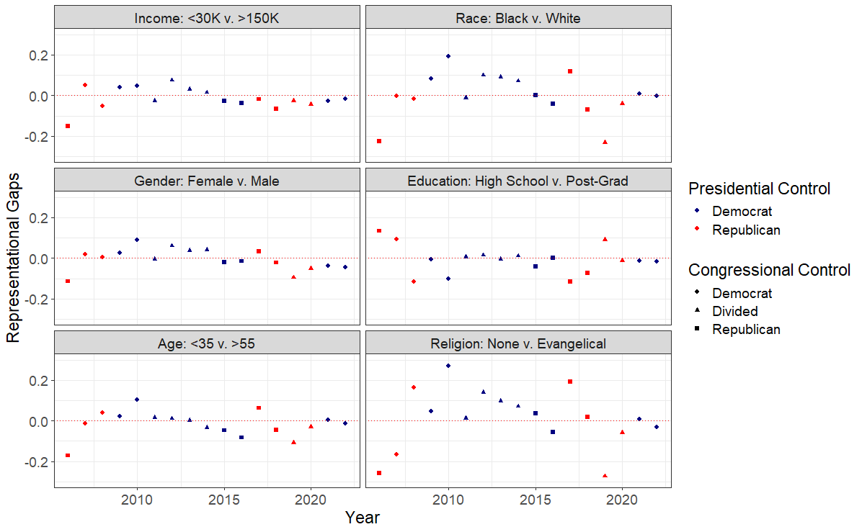
Note: In each pane, values represent the first group’s weighted win rate minus that of the second group with higher values indicating the first group is advantaged relative to the second group. Points are colored based on the presidency with shapes determined by control over Congress.
Party Control and Representational Disparities
It is clear that representational disparities do exist at intervals in our data and the disparities we find during these intervals are large. What then explains this variation over time? As noted, we believe that party control is likely to be a very important part of the explanation. In an era of heightened polarization, whether Democrats or Republicans govern should affect who wins and who loses on policy. In particular, as control of national lawmaking shifts between the parties, policy responsiveness may shift from favoring one party’s core supporters to the others’.
Looking back at Figure 2, it appears that party control does strongly shape who win and loses. While we find limited disparities in policy responsiveness when pooling all the years in our study, we find substantial disparities under different forms of partisan control.
In Figure 3 we investigate these partisan differences more systematically. The figure provides a coefficient plot that compares the effects of various demographic identities on policy win rates under Democratic and Republican presidencies. It shows how responsiveness differs based on the presidents’ party and based on party trifectas (that is, unified control of the House, Senate, and presidency by a single party—about 20% of our sample). While trifectas offer insights into a more complete form of party control, control of the presidency allows us to leverage our complete dataset. Particularly, few CES questions in our sample take place during Republican trifectas as many of the contentious congressional debates during the 2017-2018 Republican trifecta were about nominations, which we exclude from our main analysis. In robustness tests in SI-I, we show that control of the presidency and the Senate are the most important institutions for shaping the patterns observed. For these analyses, we use multivariate models similar to those used previously.

Figure 3: Multivariate Analysis by Party Control
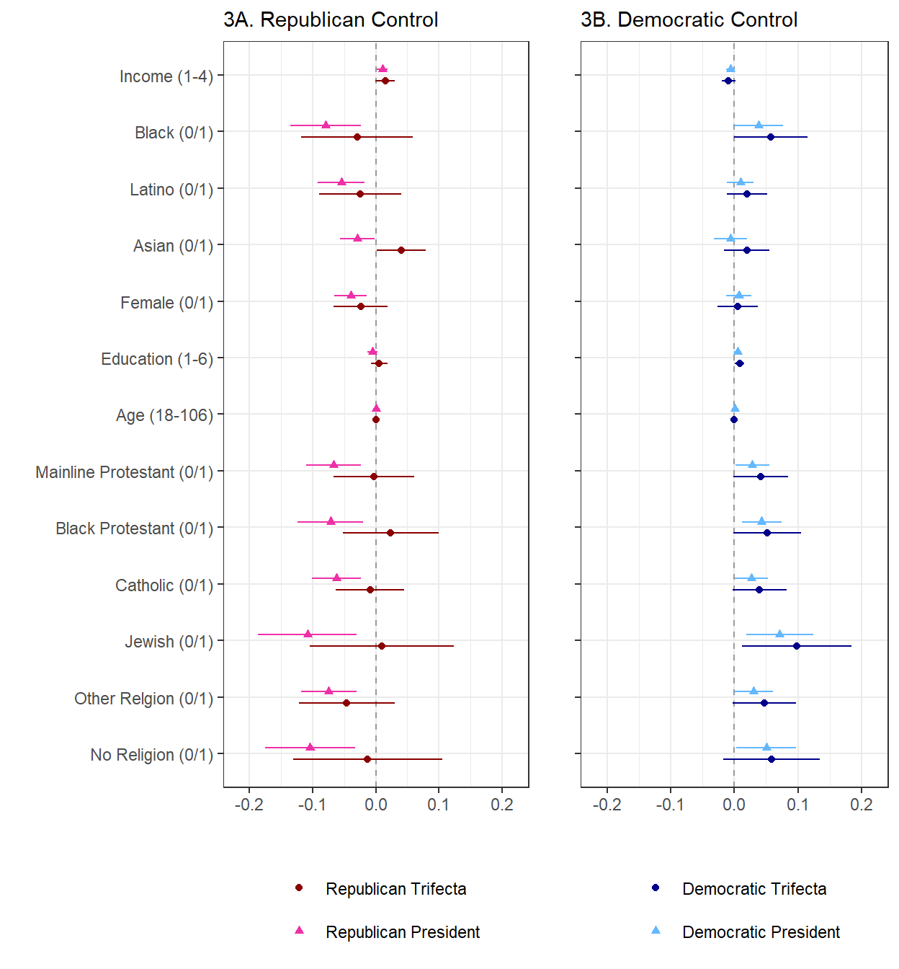
Note: Income is measured on a 4-point ordinal scale (1 = Less than $29,999, 2 = $30,000-69,999, 3 = $70,000 – 149,999, 4 = More than $150,000). Racial groups are binary indicators and “White” is the reference category. Female is a binary indicator and “male” is the reference category. Education is measured on a 6-point scale (1 = Did not graduate high school, 2 = High school graduate, 3 = Some college (but no B.A.), 4 = 2-year college degree, 5 = 4-year college degree, 6 = Postgraduate degree). Age is a continuous variable. Religions are binary indicators and “Evangelical Protestant” 0is the excluded category. All models use CES question fixed effects and cluster-standard errors. Models use CES common content weights. Full model results are available in SI-E.
As the figure shows, representational disparities change dramatically as party control shifts. Very different groups of Americans win when Republicans control policy versus when Democrats do. Under Republican control, being higher-income, White, Protestant, and male greatly increases one’s chances of winning. Under Democratic control, being highly educated, Black, or a religious minority member increases one’s chances of winning.
We start with income, which, recall, had no relation to overall responsiveness in our prior analysis. Under Republican presidents and trifectas, income has a pronounced positive effect on policy responsiveness, suggesting that more affluent voters win on policy more often than poorer voters when Republicans are in office—a finding consistent with Rhodes and Schaffner’s (2017) and Grossman et al’s (2021). When controlling for other individual-level characteristics, those making $150,000+ a year win about 3 percentage points more often than those making less than $30,000 when the president is Republican (p < 0.05) and 4.5 percentage when Republicans enjoy a trifecta (p = 0.08).
Race also matters. Under Republican presidencies, the coefficients for Black, Latino, and Asian respondents are negative, large, and statistically significant indicating lower policy win rates for these groups compared to White respondents. White Americans win on policy issues 7.9, 5.5, and 2.8 percentage points more often than Black Americans, Latinos, and Asian Americans respectively under a Republican president when controlling for other individual-level characteristics. Similar, but smaller, effects observed under the few years of Republican trifectas for Black Americans and Latinos.
Gender also has significant effects. Under Republican presidents, male respondents win on policy substantially more often than female respondents, with a 4 percentage point gap in responsiveness controlling for other individual-level characteristics.
Religion may be one of the most central divisions. Under Republican presidencies, Evangelical Protestants (the excluded category) are better represented than all other religious groups by significant margins, ranging from 6.2 to 10.8 percentage-point higher win rates with the largest gap observed between Evangelical Protestants and Jewish Americans and Evangelical Protestants non-religious people.
Neither age nor education are associated with representational differences under Republican governments.
Finally, where one lives is also associated with representation. Though these tests only allow us to leverage half the sample because of data constraints, they suggest under Republican presidents Americans who live in more rural areas enjoy significantly better representation than their more urban counterparts (see SI-D). Those that live in entirely rural zip codes win on policy about 7.4 percentage points more than those that live in entirely urban or suburban zip codes when a Republican is president.
As Figure 2B reveals, the winning coalition is very different when Democrats control the levers of power. When they are the governing party, more well-educated Americans, racial and ethnic minorities, non-Evangelicals, and, perhaps surprisingly, older Americans tend to win more on policy. Inequalities in representation under Democrats, however, are much more limited in size than they are under Republicans. Poorer Americans appear to receive marginally better representation than richer Americans, while female respondents may be getting slightly better representation than male respondents, but the latter difference is not statistically significant.
All three large racial and ethnic minority groups enjoy better representation than White Americans under Democratic trifectas, though the effect only approaches statistical significance for Black Americans (p = 0.06; this effect is significant at p < 0.05 when “Black Protestant” is not included as a control). Black respondents exhibit higher policy win rates (3.9 percentage points) compared to White respondents (the excluded category) under Democratic presidencies and Democratic trifectas (5.7 percentage points). For Latino and Asian Americans, the coefficients are smaller and non-significant (and in the case of Asian Americans, inconsistent between Democratic presidential control and Democratic trifectas).
With regard to income and education, effects appear mixed. Lower income Americans may win marginally more often than higher income Americans under Democratic presidents (p = 0.09), but not trifectas, with respondents making less than $30,000 a year winning about 1.8 percentage points more often than those making over $150,000 a year. By contrast, formal education has a more consistent and positive effect on responsiveness when Democrats control the presidency or hold a trifecta, with those with post-graduate degrees winning 2.5 and 4.6 percentage points more often than those with those without high school degrees (p = 0.06; p < 0.05).
Older respondents (measured continuously from 18 to 106) may also have higher policy win rates under Democratic presidents—each 10 years of age is associated with about a 0.6 percentage point increase in responsiveness under Democratic presidencies (p = 0.09).
Representational disparities are clearer under Democrats when it comes to religion. Under Democratic presidents, Jewish respondents have notably higher policy win rates (7.1 percentage points) than do Evangelical Protestants. The coefficients for other religious groups (Mainline Protestants Catholics, Black Protestants, the non-religious, and other religions) show smaller positive effects ranging from 2.8 to 5 percentage points. Even larger effects are seen under Democratic trifectas for these groups.
To illustrate how large these partisan effects can be, we construct two hypothetical citizens, each an amalgam of the groups most favored under each party. Our hypothetical Republican is a 65-year-old affluent ($150,000 or more yearly income) white male Evangelical Protestant with a high school degree. Our hypothetical Democrat is a 25-year-old working class ($30,000 - $69,999 yearly income) Black non-religious woman with a college degree. How often would each of these hypothetical citizens win on policy over 8 years of Republican or Democratic control?
Our Republican would win on policy issues about 58 percent of the time under a Republican president and only 47.5 percent of the time under a Democratic president. In other words, he goes from winning on a clear majority of policies under Republicans to losing on a small majority under Democrats. Our Democrat faces even greater whiplash: she would win about 57.5 percent of the time under a Democratic president and only about 30.5 percent of the time under a Republican president. In other words, she goes from winning most of the time to losing on over 2 out of 3 policy debates (and when she does win, it is generally on policies with near unanimous support).
Thus, consistent with the model coefficients, party control matters more for loyal Democrats than loyal Republicans. This may be because voters who combine party-favored characteristics are so much more common among Republicans than among Democrats. In our sample, for instance, there are more White Protestants over the age of 55 without a college degree than the total number of Latinos. More broadly, the Democratic electorate features more overlapping identities than the Republican, which may make it easier for Republicans to target their voters.
In short, whether Democrats or Republicans govern greatly affects who wins and who loses on policy. This should not be surprising in an era of heightened partisan polarization, where the electoral bases and policy agendas of the parties have become more distinct. Yet it has not featured prominently in the scholarship on unequal responsiveness.
Understanding Partisan Disparities in Win Rates
Why might party control tilt policy responsiveness away from one distinct set of voters and toward another? As discussed, seminal work on party competition suggests that, in America’s two-party system, both parties are incentivized to moderate on policy to attract support from as many voters as possible (Downs 1958). Related scholarship suggests that loyal party voters are likely to be “captured” by their party, which can safely ignore their preferences (Frymer 1999). This line of reasoning suggests that, irrespective of the party in power, moderate voters should win on policy more often than more ideologically extreme voters, while loyal party voters should lose more often than swing voters. However, other work suggests that parties today rely more on core coalition members to fund and operate their campaigns (Cowburn 2024). Thus, parties in contemporary America may be better understood as coalitions of intense demanders (Bawn et al. 2012). If these new dynamics dominate, we should expect representation to favor the party's base over the median voter.
We can offer only a limited test of party responsiveness to moderates with our data: whether those with middle-of-the-road viewpoints on policy end up winning on policy more than Americans with more extreme views on policy. Figure 4 plots weighted win rates by ideological self-identification under Republican and Democratic presidents (we see similar results when plotting win rates by self-identified partisanship, see SI-J). The results do not suggest that moderates are greatly advantaged. Instead, liberal (but not the most liberal) respondents win more on policy when Democrats control the White House, and the most conservative win more on policy when Republicans do. Moderates win more under Democratic presidents than under Republican presidents but not more overall.

Figure 4: Win Rates Based on Respondents' Ideologies
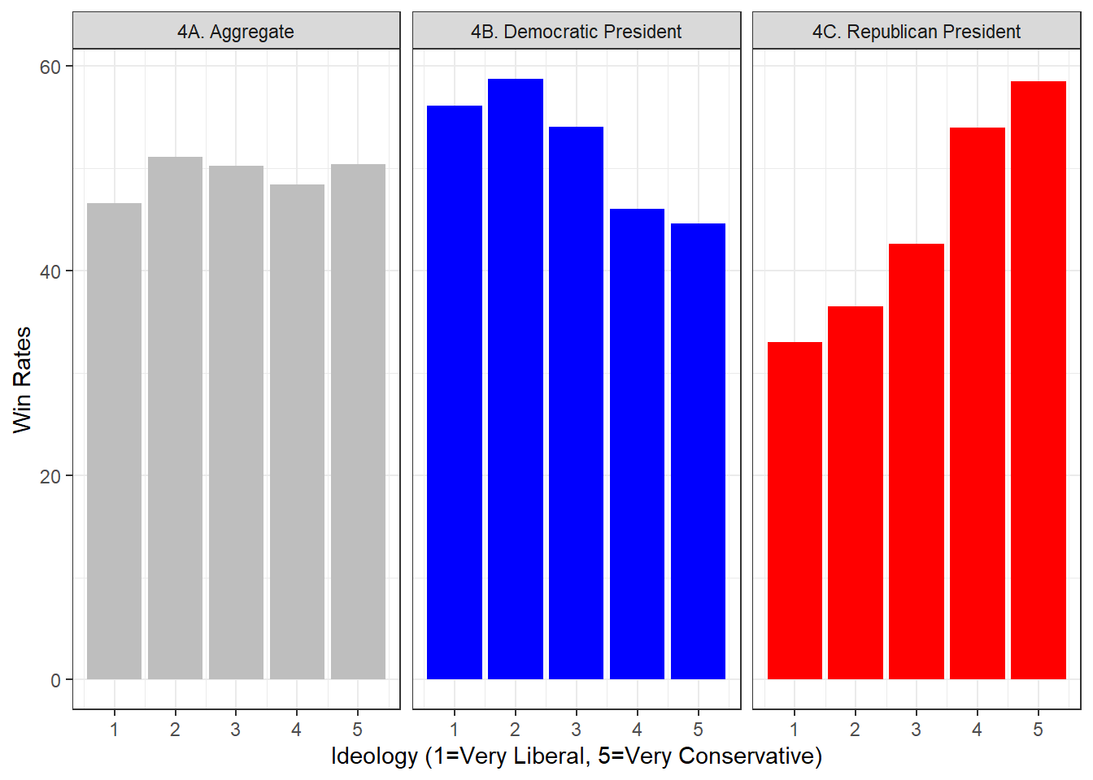
In short, neither median-voter expectations nor theories of group capture receive strong support in our (admittedly limited) test. We leave the question of why to scholars with better capacity to dig into the specifics, including whether voters who are more likely to switch between the parties over time receive better representation—which we cannot test with our repeated opinion cross-sections.
What we can say with greater confidence is that the two major political parties appear to respond more to their electoral base than to voters more aligned with the competing party. Figure 5A plots the marginal increase in win rates under Democratic presidencies versus Republican presidencies for each set of voters. Figure 5B does the same thing based on trifectas (the average is above 0 as the mean win rate is higher under Democratic control). The y-axis of both panels plots the win-rate difference for different demographic groups between Democratic and Republican control of the White House; the x-axis of both panels plots the relative House vote share advantage of the Democratic party over the Republican party for each demographic group.

Figure 5: Win Rate Differences by Vote Share Differences
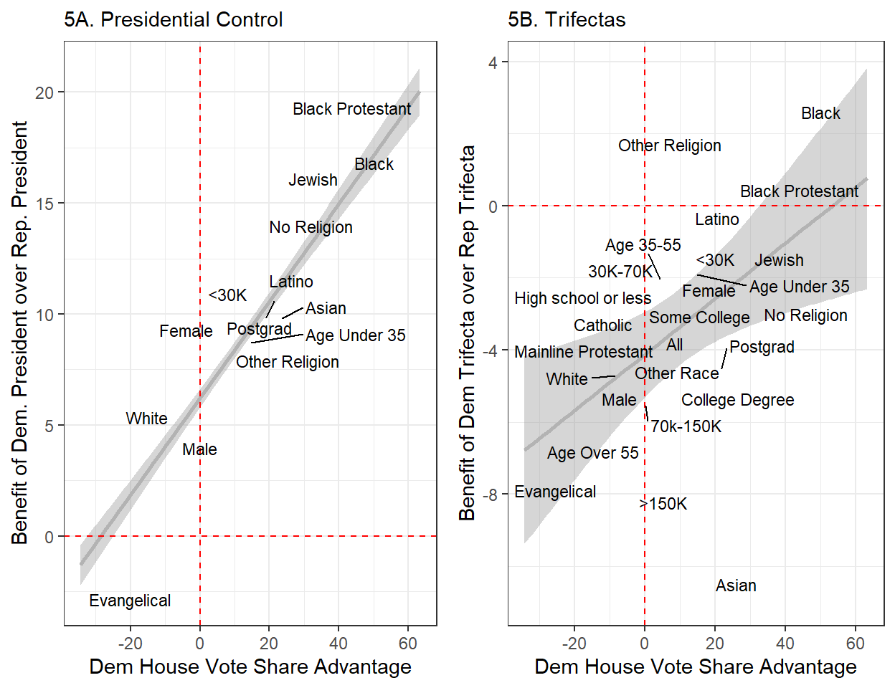
As seen in both panels, voters of color (particularly Black voters), more educated voters, and religious minorities are stronger supporters of the Democratic Party according to their House vote. In contrast, White, Evangelical Protestant, older, and (more recently) voters without a college degree are stronger supporters of the Republican. Both panels suggest that voting blocs more closely aligned with the Democratic Party see the highest relative win rates when Democrats control government while the same is true for voting blocs more closely aligned with the Republican when Republicans control government. These findings are broadly consistent with theories of coalitional party politics, suggesting parties seek to represent their core constituencies.
Two additional findings suggest that parties reward their strong supporters. First, members of the public who are in fact members of each party (or who are ideologically aligned with the party), win more than members of the public who are not. Second, controlling for party and ideology reduces (but does not eliminate) the effects of demographic factors on party-based representation.
These results are presented in the two panels in Figure 6, where we add a control for self-reported party identification to our presidential party control regression models. We see that party identification greatly shapes who wins under both Democratic and Republican presidents, with aligned partisans receiving greater representation. Moreover, comparing the coefficients across the different models in the figure, the effects of demographic variables decline markedly when respondents’ party identification is added. Apparently, while these demographic variables strongly predict who favors which party, they are not as precise as partisan identity itself.
In the left panel, for example, the coefficients that once suggested Republicans overrepresent the wealthy and underrepresent women, racial and ethnic minorities, and religious minorities shrink substantively when accounting for party ID. While most remain statistically significant or approach statistical significance (i.e., p < 0.1), all the demographic coefficients noticeably shrink across the board once we control for respondents partisan identification.
In the right panel, we see similar, if not stronger, patterns under Democratic control: racial minorities and those with more formal education no longer see a representation advantage under Democratic presidents. Religious minorities receive slightly better representation under Democratic presidents than do Evangelical protestants, but in many cases, the coefficients are no longer statistically significant and those that remain statistically significant are substantively much smaller. Older voters, however, continue to see representational advantages under both patterns of party control even when accounting for their party identification.
We continue to observe slightly different patterns under Republican and Democratic control. Republican control tends to favor majoritarian and better resourced groups while Democratic control favors a more diverse coalition of less powerful and minoritized groups. Furthermore, even when controlling for party ID, group-based disparities are larger and more likely to be statistically significant under Republican control compared to under Democratic control, where win rates are closer to equal across groups.
Figure 6: Multivariate Analysis with PID Control by Presidential Party Control 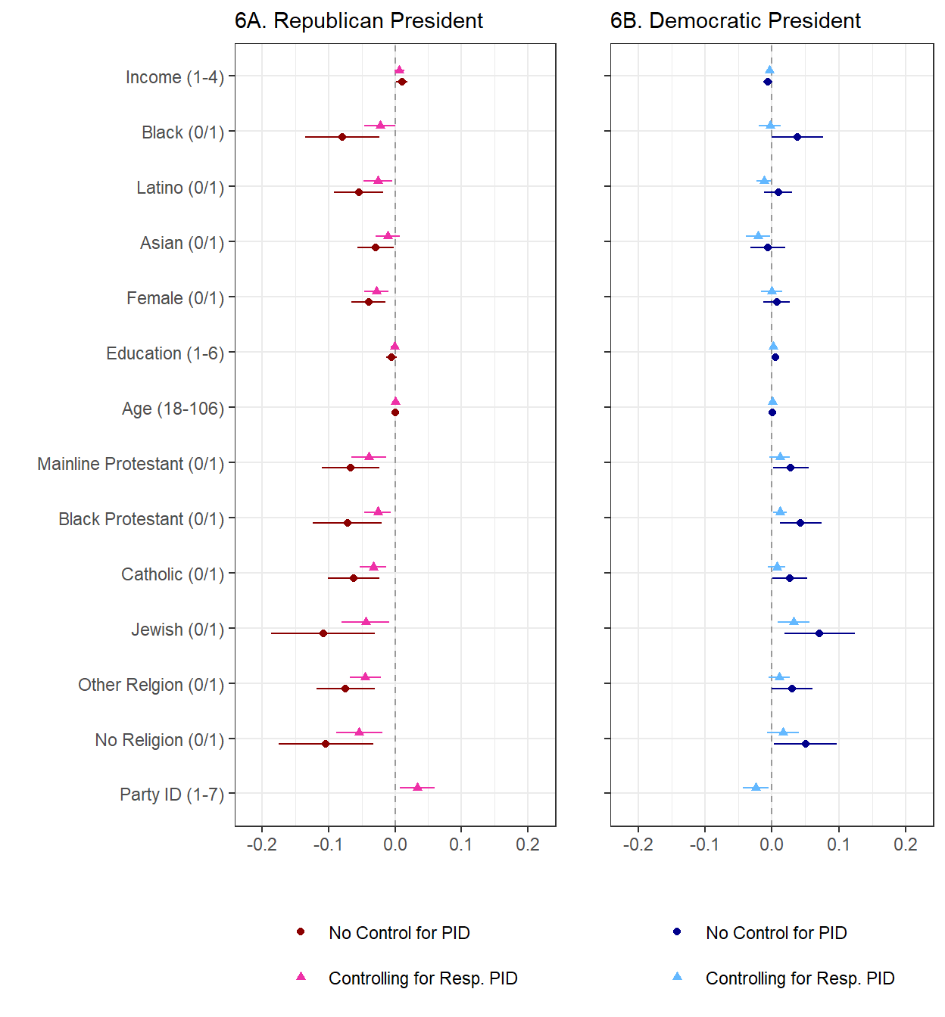Note: Income is measured on a 4-point ordinal scale (1 = Less than $29,999, 2 = $30,000-69,999, 3 = $70,000 – 149,999, 4 = More than $150,000). Racial groups are binary indicators and “White” is the reference category. Female is a binary indicator and “male” is the reference category. Education is measured on a 6-point scale (1 = Did not graduate high school, 2 = High school graduate, 3 = Some college (but no B.A.), 4 = 2-year college degree, 5 = 4-year college degree, 6 = Postgraduate degree). Age is a continuous variable. Religions are binary indicators and “Evangelical Protestant” is the excluded category. All models use CES question fixed effects and cluster-standard errors. Full model results are available in SI-E.

In sum, parties appear to try to respond to the preferences of their core constituencies, who receive better representation relative both to moderates and the other party’s strong backers when their party is in charge. As we show in SI-L and SI-M, they do so both by passing policies their base supports and blocking those their base opposes. Republicans in power prioritize issues popular with wealthier, White, male, older, Protestant, and less-educated voters, while Democrats are more responsive to lower-income, Black, female, younger, highly educated, and Jewish voters. Consistent with models of negative agenda control, however, blocking items is more important to the representation of the base than passing items. Nonetheless, both these Appendix analyses and the findings reported in this section strongly suggest that leaders of both parties wield agenda power to advance their electoral coalition’s priorities.
Conclusion
Decisions of a government should, at least in part, reflect the views of its public. Do they? To tackle this foundational question, we draw on a uniquely rich dataset that allows us to examine the alignment between citizen preferences and policy outcomes on 133 salient policy items over nearly twenty years. In doing so, we contribute to three major traditions in the study of representation: research on unequal group-based influence, models of party strategy rooted in swing voter logic, and more recent theories that center parties and their core coalitions.
With regard to the first, we build on a large literature examining whether certain social groups—particularly those with more resources or status—receive better representation than others. We contribute to this line of inquiry by providing the first large-scale, individual-level analysis of responsiveness across a wide range of issues and over an extended time span. Unlike most prior work that focuses on only one axis of conflict, we analyze multiple cleavages simultaneously—including income, race, age, gender, and religion—allowing us to assess group disparities in responsiveness with greater nuance.
With regard to the second tradition, we engage directly with median voter theories of party behavior, which posit that electoral competition leads parties to converge on the preferences of swing voters. Our findings challenge this model. We find little evidence that parties prioritize the ideological middle when in power, and strong evidence that they instead cater to their core electoral constituencies.
Finally, with regard to the emerging third tradition that centers political parties as coalitions of intense demanders, we provide what we believe is the clearest empirical demonstration to date that party control conditions the representational landscape. The groups that win on policy shift markedly depending on which party governs.
The shifting fortunes of parties’ core voters only come into view when we look at outcomes based on party control. When we aggregate across our dataset, the representation gaps most discussed in existing studies appear surprisingly muted. Yet these aggregate results belie dramatically shifting patterns of responsiveness over time as partisan control changes. When Republicans are in charge, policy tends to favor the preferences of White Americans, Evangelical Protestants, men, and the wealthy. When Democrats hold power, Black Americans, those with higher education, and religious minorities win more often on policy.
Moreover, these advantages and disadvantages are cumulative across cleavages. As in our illustrative example, a 65-year-old affluent white male Protestant with a high school degree receives advantages under Republican control based on his age, gender, race, religion, and education. Our hypothetical 25-year-old working-class Black non-religious woman with a college degree receives advantages under Democratic control for the same reasons. And both are disadvantaged when the party favoring voters like them is out of power, with the gaps largest for our hypothetical Democrat. While winning over half the time when a Democrat is president, she loses nearly three-quarters of the time when a Republican is.
These disparities closely track the demographics of party allegiance. Groups that overwhelmingly support the Democratic Party—such as Black Americans, Latinos, college graduates, and non-religious Americans—win disproportionately when Democrats hold power. Groups that overwhelmingly support the Republican Party—men, Whites, higher-income Americans, Protestants, and (in recent years) non-college voters—win disproportionately when Republicans hold power. Each party uses control of government to reward core segments of its coalition by passing items they like and (especially) blocking items they dislike.
This finding not only provides a new window on unequal responsiveness; it also engages with long-standing theories of party competition. According to prevailing approaches inspired by Downs (1957), parties should converge toward the preferences of swing voters, as those in the ideological middle are pivotal for winning elections (Fowler et al. 2022). Loyal partisans, by contrast, are “captured” constituencies who can be taken for granted (Frymer 1999). Our results join a growing body of work that troubles this view, showing instead that parties prioritize their base when in power, consistent with theories that treat parties as coalitions of intense demanders (Bawn et al. 2012). The evidence we find of party-based responsiveness to core voters aligns with work suggesting that changing party dynamics—caused by partisan primaries, media segmentation, and the rise of party-aligned groups—diminish pressure to moderate and increase pressure to deliver for intense demanders (Achen and Bartels 2016; Levendusky 2013; Cowburn 2024).
Our findings also speak to—and complicate—prior studies of unequal responsiveness. While Gilens (2012) and Gilens and Page (2014) documented stark income-based disparities during an earlier period, our analysis suggests that such disparities are smaller today and more contingent on who holds power. We do not interpret our results as overturning theirs, but as contributing to an evolving empirical debate about the durability and scope of representational inequality in an era of heightened polarization. Our broader time frame, focus on final policy outcomes, and multi-cleavage, individual-level design offer a distinct vantage point from which to assess these dynamics.
We caution against interpreting muted class (or other demographic) disparities in our pooled analysis as evidence of a level playing field. Yes, representation appears balanced in the aggregate, but this balance is an artifact of partisan oscillation. The relatively even split in party control over the past two decades has produced an average result that masks the key pattern: each party rewards its base when in power. These effects have offset one another in our data, but this averaging out is contingent on continued power alternation. If one party were to gain long-term control, representation would likely tilt sharply toward its core constituencies, with little responsiveness to opposing groups.
To judge the see-saw pattern of representation we find, we need far more data on how responsiveness (or its absence) affects material well-being for different groups. There is suggestive evidence that Republicans and Democrats produce differing economic effects for different groups when they govern at the national level (Hajnal 2025; Hajnal and Horowitz 2014; Bartels 2008, 2016). Many of the policies Congress passes and the president signs—and many counterfactual scenarios involving blocked policies—result in profound effects that are not easily reversed. Notwithstanding obvious examples (the Affordable Care Act, the Trump tax cuts), we lack good evidence on these cumulative effects, nor can we assume that when Democrats or Republicans hold power, they are equally capable of generating them. Without such investigation, the full impact of our findings remains unclear.
There is also a need for studies that extend beyond our focus on high-profile federal issues to include lower-salience issues, state and local policymaking, and non-legislative forms of representation, such as symbolic and descriptive representation. It may be that the partisan dynamics we find are more muted in these other domains and that more stable group-based advantages emerge. Of course, salient national issues often involve large policy consequences, so better understanding representation on these issues—including its direct consequences for citizens’ lives—must be a priority, too.
Still, the patterns of representation we observe depart not only from a model of consistent demographic bias, but also from a model of convergence on the median voter. Instead, our results suggest a dynamic form of conditional representation, in which responsiveness varies systematically with partisan control and the alignment between governing coalitions and key social groups. A democracy in which voters most loyal to the party in power win, while those on the other side lose, is very different from the one most thought existed even a few decades ago.

References
Abramowitz, A. I. (1994). Issue Evolution Reconsidered: Racial Attitudes and Partisanship in the U.S. Electorate. American Journal of Political Science, 38(1), 1–24. https://doi.org/10.2307/2111333
Ansolabehere, S. & Kuriwaki, S. (n.d.) Collective Representation in Congress. Unpublished manuscript.
Ansolabehere, Stephen, and Shiro Kuriwaki. "Congressional representation: Accountability from the constituent's perspective." American Journal of Political Science 66, no. 1 (2022): 123-139.

Ansolabehere, S., & Schaffner, B. F. (2014). Does Survey Mode Still Matter? Findings from a 2010 Multi-Mode Comparison. Political Analysis, 22(3), 285–303.
Bartels, L. M. (2008). Unequal Democracy: The Political Economy of the New Gilded Age (STU-Student edition). Princeton University Press. https://www.jstor.org/stable/j.ctt7t9ks
Bonica, A., & Grumbach, J. M. (2022). Old money: Campaign finance and gerontocracy in the united states. Available at SSRN 4892936.

Broockman, D. E. (2016). Approaches to Studying Policy Representation. Legislative Studies Quarterly, 41(1), 181–215. https://doi.org/10.1111/lsq.12110
Browning, R. P., Marshall, D. R., & Tabb, D. H. (1984). Protest is not enough: The struggle of blacks and Hispanics for equality in urban politics. University of California Press.
Butler, D. M., & Broockman, D. E. (2011). Do Politicians Racially Discriminate Against Constituents? A Field Experiment on State Legislators. American Journal of Political Science, 55(3), 463–477.
Caughey, D., & Warshaw, C. (2018). Policy Preferences and Policy Change: Dynamic Responsiveness in the American States, 1936–2014. American Political Science Review, 112(2), 249–266. https://doi.org/10.1017/S0003055417000533
Clifford, S. (2012). Reassessing the unequal representation of Latinos and African Americans. The Journal of Politics, 74(3), 903-916.
CNN. 2024. "Election 2024: Exit Polls." https://www.cnn.com/election/2024/exit-polls/national-results/general/president/0
Culpepper, P. D. (2010). Quiet Politics and Business Power: Corporate Control in Europe and Japan. Cambridge University Press. https://doi.org/10.1017/CBO9780511760716
Dahl, Robert A., 1915-2014. (1964). Who governs? Democracy and power in an American city. New Haven :Yale University Press,
Downs, A. (1957). An economic theory of democracy. Harper.
Ellis, C. R., & Ura, J. D. (2008). United We Divide?: Education, Income, and Heterogeneity in Mass Partisan Polarization (SSRN Scholarly Paper 1302856). https://doi.org/10.2139/ssrn.1302856
Enns, P. K. (2015). Relative Policy Support and Coincidental Representation. Perspectives on Politics, 13(4), 1053–1064. https://doi.org/10.1017/S1537592715002315
Fowler, A., Hill, S. J., Lewis, J. B., Tausanovitch, C., Vavreck, L., & Warshaw, C. (2023). Moderates. American Political Science Review, 117(2), 643–660. https://doi.org/10.1017/S0003055422000818
Gilens, M. (2005). Inequality and Democratic Responsiveness. The Public Opinion Quarterly, 69(5), 778–796.
Gilens, M. (2012). Affluence and Influence: Economic Inequality and Political Power in America. Princeton University Press. https://doi.org/10.2307/j.ctt7s1jn
Gilens, M., & Page, B. I. (2014). Testing Theories of American Politics: Elites, Interest Groups, and Average Citizens. Perspectives on Politics, 12(3), 564–581. https://doi.org/10.1017/S1537592714001595
Griffin, J. D., & Newman, B. (2008). Minority Report: Evaluating Political Equality in America. University of Chicago Press. https://press.uchicago.edu/ucp/books/book/chicago/M/bo5786242.html
Griffin, J. D., Newman, B., & Wolbrecht, C. (2012). A Gender Gap in Policy Representation in the U.S. Congress? Legislative Studies Quarterly, 37(1), 35–66. https://doi.org/10.1111/j.1939-9162.2011.00034.x
Grumbach, J. M. (2023). Laboratories of Democratic Backsliding. American Political Science Review, 117(3), 967–984. https://doi.org/10.1017/S0003055422000934
Hacker, J. S., Hertel-Fernandez, A., Pierson, P., & Thelen, K. (2021). The American Political Economy: Politics, Markets, and Power. Cambridge University Press.
Hajnal, Z. L., & Horowitz, J. D. (2014). Racial winners and losers in American party politics. Perspectives on Politics, 12(1), 100-118.
Hero, R. E. (1992). Latinos and the U.S. political system: Two-tiered pluralism. Temple University Press.
Huber, E., & Stephens, J. D. (2001). Development and Crisis of the Welfare State: Parties and Policies in Global Markets. University of Chicago Press. https://press.uchicago.edu/ucp/books/book/chicago/D/bo3633601.html
Hunter, F. (1953). Community Power Structure: A Study of Decision Makers. University of North Carolina Press.
Identity Politics and Trade Policy | The Review of Economic Studies | Oxford Academic. (n.d.). Retrieved August 26, 2024, from https://academic.oup.com/restud/article/88/3/1101/5858143
Kuriwaki, S., Ansolabehere, S., Dagonel, A., & Yamauchi, S. (2023). The geography of racially polarized voting. American Political Science Review, 1-18. doi:10.1017/S0003055423000436
Lajevardi, N. (2020). Access denied: Exploring Muslim American representation and exclusion by state legislators. Politics, Groups, and Identities, 8(5), 957–985. https://doi.org/10.1080/21565503.2018.1528161
Lax, J. R., Phillips, J. H., & Zelizer, A. (2019). The Party or the Purse? Unequal Representation in the US Senate. American Political Science Review, 113(4), 917–940. https://doi.org/10.1017/S0003055419000315
Layman, G. C., Carsey, T. M., & Horowitz, J. M. (2006). Party polarization in American politics: Characteristics, causes, and consequences. Annu. Rev. Polit. Sci., 9(1), 83-110.
Lewis, Jeffrey B., Keith Poole, Howard Rosenthal, Adam Boche, Aaron Rudkin, and Luke Sonnet (2024). Voteview: Congressional Roll-Call Votes Database. https://voteview.com/
Maks-Solomon, C., & Rigby, E. (2020). Are Democrats Really the Party of the Poor? Partisanship, Class, and Representation in the U.S. Senate. Political Research Quarterly, 73(4), 848–865. https://doi.org/10.1177/1065912919862623
Markarian, G. A. (2024). Racially Disparate Policy Responses to Mass Shootings. Political Research Quarterly, 77(1), 297–315. https://doi.org/10.1177/10659129231209323
Mathisen, R. B. (2023). Affluence and Influence in a Social Democracy. American Political Science Review, 117(2), 751–758. https://doi.org/10.1017/S0003055422000739
Mathisen, Ruben B. "The influence gap: unequal policy responsiveness to men and women." The Journal of Politics 86, no. 4 (2024): 1368-1381.

McCall, L. (2005). The Complexity of Intersectionality. Signs, 30(3), 1771–1800. https://doi.org/10.1086/426800
Miller, W. E., & Stokes, D. E. (1963). Constituency Influence in Congress. American Political Science Review, 57(1), 45–56. https://doi.org/10.2307/1952717
November 22, ohtadmin on & 2020. (2020, November 22). Deciphering how Jewish Americans voted has become muddled in 2020—Jewish Press of Tampa. Jewish Press of Tampa -. https://www.jewishpresstampa.com/articles/decifering-how-jewish-americans-voted-has-become-muddled-in-2020/
Nteta, T. M., Rhodes, J. H., & Tarsi, M. R. (2016). Conditional Representation: Presidential Rhetoric, Public Opinion, and the Representation of African American Interests. Journal of Race, Ethnicity, and Politics, 1(2), 280-315.
Page, B. I., & Shapiro, R. Y. (1992). The rational public: Fifty years of trends in Americans’ policy preferences. University of Chicago Press.
Pierson, Paul. "Goodbye to Pluralism? Studying Power in Contemporary American Politics." In Wildavsky Forum for Public Policy, Goldman School of Public Policy, Berkeley, CA. 2015.
Rhodes, J. H., & Schaffner, B. F. (2017). Testing Models of Unequal Representation: Democratic Populists and Republican Oligarchs? Quarterly Journal of Political Science, 12(2), 185–204. https://doi.org/10.1561/100.00016077
Schattschneider, E. E. (1960). The Semisovereign People: A Realist’s View of Democracy in America. Holt, Rinehart and Winston.
Should Blacks Represent Blacks and Women Represent Women? A Contingent “Yes” on JSTOR. (n.d.). Retrieved August 26, 2024, from https://www.jstor.org/stable/2647821
Soroka, S. N., & Wlezien, C. (2008). On the Limits to Inequality in Representation. PS: Political Science and Politics, 41(2), 319–327.
Soroka, S. N., & Wlezien, C. (2009). Degrees of Democracy: Politics, Public Opinion, and Policy. Cambridge University Press. https://doi.org/10.1017/CBO9780511804908
Stephanopoulos, N., & McGhee, E. (2015). Partisan Gerrymandering and the Efficiency Gap. University of Chicago Law Review, 82(2). https://chicagounbound.uchicago.edu/uclrev/vol82/iss2/4
Stimson, J. A. (1999). Public opinion in America: Moods, cycles, and swings (2nd ed). Westview Press.
Strolovitch, Dara Z., Invisible Ink: Intersectionality and Political Inquiry, 1 Ind. J.L. & Soc. Equality 100 (2013).
Toward a more responsible two party system. Report of the Committee on Political Parties of the American Political Science Association. New York: Rinehart and Company. I950. PP. xi, 99.
The Democratic Deficit in the States—Lax—2012—American Journal of Political Science—Wiley Online Library. (n.d.). Retrieved August 26, 2024, from https://onlinelibrary.wiley.com/doi/full/10.1111/j.1540-5907.2011.00537.x
Thernstrom, S., & Thernstrom, A. (1999). America in Black and White: One Nation, Indivisible. Simon and Schuster.
Uneasy Alliances: Race and Party Competition in America. (1999). Princeton University Press. https://www.jstor.org/stable/j.ctt7sq6f
Visalvanich, N. (2017). Asian Candidates in America: The Surprising Effects of Positive Racial Stereotyping. Political Research Quarterly, 70(1), 68–81. https://doi.org/10.1177/1065912916674273

There is a small but important literature that has examined the role of parties in mediating unequal responsiveness by class, offering strong evidence that Republican elected officials are distinctively responsive to the affluent. These studies, however, tend to focus narrowly on MCs’ behavior (Lax, Phillips, and Zelizer 2019; Rhodes and Schaffner 2017; Grossman, Mahmood, and Isaac 2021) and have not considered a broader range of voter characteristics (such as race and gender), nor linked these disparities to systematic demographic differences in the partisan allegiance of voters.
We look at this set of cleavages for two reasons. First, the CES consistently records these identities from respondents even if the exact question wording and answer choices may slightly vary from year to year. Second, they represent an important set of cleavages that are often linked to disparities in political power in the American politics literature. We stop short of looking at intersectional identities (e.g., Black women) because of space limitations but encourage future research to explore related questions about intersectionality.
It is not a full picture for another reason: we can only assess departures from the status quo, which already may be highly favorable to resourceful political actors (Pierson 2015).
Policy responsiveness is, of course, only one criterion on which the democratic process should be judged. Other important aspects of representation include descriptive and symbolic representation as well as whether government actions lead to economic growth and foster equality (Mansbridge 1999; Hajnal and Horowitz 2016). It is also important to note that responsiveness to the will of the public is not always warranted or beneficial. Here, concerns related to the tyranny of the majority and the potential violation of core rights come to the fore.
Democracy is, of course, associated with both winning and losing. There will be winners and losers in any policy contest. But if individuals and groups that lose more tend to lose consistently across a range of policy areas and across a long-time frame, then fears about fairness and exclusion emerge.
Some research has found that race plays little role in shaping policy outcomes (Clifford 2012), either because racial differences in policy views are minimal or because policymakers are more even-handed than some scholars suggest (see, e.g., Abramowitz 1994; Thernstrom and Thernstrom 1997; Visalvanich 2016). The same variability exists in other dimensions, such as gender and age, depending on the locus of policymaking (Stephanopoulos 2015). Given these divergent findings, it is challenging to make definitive statements about how well different groups are represented in federal policymaking.
However, Stephanopoulos (2015) is only able to examine one dimension at a time and Griffin and colleagues (2019) are only able to look at one aspect of policy – changes in federal government spending patterns.
To cite one example, in the 2024 presidential contest, most White Americans (57 percent), voted for Donald Trump, while most Blacks (87 percent), Asian Americans (55 percent), and Latinos (51 percent) favored Kamala Harris. The gaps in the 2024 vote by gender (55 percent of men for Trump and 53 percent of women for Harris), age (50 percent of Americans over 60 for Trump and 54 percent of those under 30 for Harris), religion (63 percent of Protestants for Trump vs 78 percent of Jewish and 71 percent of Atheists for Harris), and urbanicity (64 percent of rural voters for Trump and 60 percent of urban voters for Harris) were also substantial (CNN 2024).
Representational disparities may be more pronounced on less visible issues, particularly those that powerful actors deliberately keep off the legislative agenda (Schattschneider 1960; Culpepper 2010). Moreover, our analysis only captures departures from the status quo, which may already be favorable to well-organized actors (Pierson 2015).
The remaining 23 items could not be matched to a specific roll call vote because the associated legislation was blocked in committee, blocked by party leaders, credibly threatened with a filibuster, or never formally introduced. Our data on roll-call votes comes from VoteView.com (Lewis et al. 2024). Where possible, we use votes on final passage of bills in both chambers. In the Senate, however, when only a cloture vote is taken (because it fails to pass the supermajority threshold), we consider the cloture vote to be equivalent to a vote on the bill itself.
In general, bills are asked about within a year of a vote, though this is not always the case and there might be as much as a 3-year gap between a vote being taken and the issue being asked about on the CES.
We do not assess dyadic representation (how legislators attend to their specific constituents), descriptive representation, or the ways members of Congress represent their constituents outside of the lawmaking process.
The urban-rural variable is available for only half the sample, so we present these results in the appendix. Our model coefficients do not much change when it is included. As with other characteristics strongly linked to partisanship—with rural voters much more likely to be Republican—we find no evidence of aggregate representational advantages for rural (or urban) residents but some evidence that rural voters are better represented when Republicans control government.
It is worth noting that dropping all of the other demographic variables from the model does not alter the finding on class. Nor does singling out specific income and educational categories in the model.
An “Other Race” category includes Native Americans, Middle Easterners, multi-racial individuals, and those that did not identify with any racial group. That coefficient is not plotted because of the difficulty of interpreting this broad categorization. Members of that category do not experience significantly higher or lower representation than White Americans over this period.
We were unable to determine the religious affiliation of 4.8% of observations using the “RELTRAD” typology, often because respondents refused to answer relevant questions when surveyed. In these cases, respondents were categorized as “unknown religion,” a statistically insignificant coefficient not displayed here.
Additional analysis in SI-F shows that adding controls for PID and ideology to our multivariate models makes little difference. The main exception is our coefficient for Latinos, which remains consistent but, because the confidence intervals shrink, is statistically significant (p = 0.04).
Only Black Protestants, Jews, and people over the age of 55 have win rates near or above 50 percent. Some smaller demographic groups and less frequent voters like Asian Americans and people under the age of 35 win on policy issues about 45 percent of the time.
In this figure and in all others, win rates are calculated weighing on the CES’s common content weights.
As in all our analyses, the years are when the policy item was on the legislative agenda, not necessarily when the CES question was asked, so we are correctly ascribing partisan effects. We do not include two pieces of legislation considered before 2006 (asked about retrospectively in the first survey wave) as they create imprecise estimates. We do not have data for 2018 because there were only nominations considered that year in Congress.
The "Other Race" category shows a negative and significant coefficient under Democratic presidencies and trifectas and Republican trifectas but a small positive effect under Republican presidencies.
As a reminder, the sample aims to represent the American electorate, not the American population.
We use House vote share because it is the most common CES vote choice question, and we are focused on lawmaking; results are similar with presidential vote share which is asked less often. See SI-K.
Differences in how income is measured may also matter. While we define “high income” as $150,000 or more, Gilens employs a more complex measure. Attempts to approximate his approach in our data would substantially reduce sample size and statistical power, making direct comparisons difficult. It is also worth noting that not all research aligns with Gilens’s. Enns (2015, 2024), for example, argues that class differences are much smaller than Gilens’ finds. Our findings, while differing from Gilens, align more closely with those of Lax et al. (2019), who show that partisan dynamics condition responsiveness in ways that depart from the median voter model. Unlike Lax and his colleagues, however, our focus is on final policy outcomes rather than roll-call votes in the Senate.

